Audio Amplifier Design Report
Author: Isaac Adjei (240191278)
Organisation: Aston University
Date: 03/03/2026
Version: 1

Statement of originality
I confirm that the work contained within this report is my own. I understand the university academic malpractice rules, including plagiarism.

Abstract
This technical report outlines the design, simulation, testing and implementation of a two-stage audio amplifier optimised for an iPhone 14 Pro Max with a 0.872 Vpp input. A TL071 (stage 1) performs stereo-to-mono summing, provides 10.67 dB gain and achieves a passband from 6.63 Hz to 28.54 kHz. An OPA551 (Stage 2) drives an 8 Ω speaker at 3 Vpp from a 9-12 V single supply. The amplifier is implemented on a PCB mounted on an acrylic baseplate.

Table of Contents
Abstract 1
1. Introduction 2
2. Technical Background 3
2.1. Human Hearing Range, Audio Frequency Bands and Stereo versus Mono Audio 3
2.2. Active Band-Pass Filters 3
2.3. The TL071 Operational Amplifier 5
2.4. The TL071 as an Inverting Summing Active Band-Pass Filter 6
2.5. The OPA551 Operational Amplifier 6
2.6. The OPA551 as a Unity-Gain Voltage Follower 6
2.7. The Two-Stage Amplifier Architecture 7
2.8. Single-Supply Operation 7
3. Design Description 7
3.1. Technical specifications 7
3.2. Overview of the design 9
3.3. Design calculations 9
3.4. Detailed description 11
3.5. PCB design 12
3.6. 3D Model from Proteus 13
4. Results 13
4.1. Prototype testing and results. 13
4.2. PCB testing and results 14
4.3. Final assembly 16
4.4. Evaluation and Conclusions 17
5. References 18
6. Appendices 18
6.1. Appendix A - Bill of Materials (BoM) 18
6.2. Appendix B - Full circuit diagram 20

Table of Figures
Figure 1: Frequency response of an ideal band-pass filter [3], [4]. 4
Figure 2: Active band-pass filter circuit [3], [4]. 5
Figure 3: Comparison of passive and active band-pass filter frequency responses [3]. 5
Figure 4: Pin configuration of the TL071 operational amplifier [1]. 7
Figure 5: Pin configuration of the OPA551 operational amplifier [2]. 7
Figure 6: Top-level block diagram of the two-stage audio amplifier system. 9
Figure 7: iPhone 14 Pro Max output voltage versus volume step at 440 Hz. 10
Figure 8: TL071CP active band-pass filter stage sub-circuit. 11
Figure 9: OPA551PA unity-gain buffer output stage sub-circuit. 11
Figure 10: PCB top layer showing component placement and silk screen. 13
Figure 11: PCB bottom layer showing copper track routing and ground plane. 13
Figure 12: Three-dimensional model of the PCB. 13
Figure 13: Simulated and measured frequency response of the first amplifier stage on breadboard with dual ±9 V power supply. 14
Figure 14: Simulated and measured frequency response of the complete two-stage amplifier on breadboard with single 9 V power supply. 14
Figure 15: Simulated and measured frequency response of the complete two-stage amplifier on the printed circuit board. 15
Figure 16: Time-domain waveforms at 440 Hz showing Vin and amplifier output across both stages. 16
Figure 17: Photographs of the completed printed circuit board assembly. 17
Figure 18: Full circuit schematic of the two-stage audio amplifier exported from Proteus. 20

Introduction
This technical report describes the design, simulation, testing and implementation of a two-stage audio amplifier capable of accepting an audio input signal from a mobile phone or MP3 player and amplifying it to drive an external speaker. The amplifier was optimised for use with an iPhone 14 Pro Max, with a design input level of 0.872 Vpp at volume step 15 of 16, corresponding to 70% of the maximum measured output at 440 Hz. The target output is 3 Vpp across an 8 Ω speaker load. The system operates from either a 12 V DC power adapter or a 9 V PP3 battery, with an on/off switch and green LED indicator included.
A two-stage architecture is employed because no single operational amplifier can simultaneously provide the required voltage gain with active band-pass filtering and the output current necessary to drive a low-impedance speaker load. The first stage uses a TL071 configured as an inverting summing active band-pass filter, combining the stereo left and right input channels into a mono signal, setting the voltage gain to 10.67 dB and defining the passband from 6.63 Hz to 28,540 Hz. The second stage uses an OPA551 configured as a unity-gain voltage follower to provide the current drive capability required to deliver 3 Vpp across the 8 Ω load, whilst preserving the voltage established by the first stage. Single-supply biasing at Vcc/2 is implemented throughout, with AC coupling capacitors blocking the DC offset from the signal path.
The design process encompasses mobile phone output characterisation, gain and filter component calculations, dual-supply and single-supply simulation in Proteus, breadboard prototyping, PCB design and fabrication and final hardware testing. Section 2 presents the relevant technical background, Section 3 describes the complete circuit design, Section 4 presents the simulation and measured results and Section 4.4 evaluates the amplifier performance against the original specification, including discussion of any deviations and recommendations for future improvement.

Technical Background
This section presents the theoretical background necessary to understand the design, implementation and evaluation of the two-stage audio amplifier described in this report. The section begins with an overview of the human audible frequency range and the characteristics of audio signals, including a discussion of frequency bands within the audible spectrum and the distinction between stereo and mono audio [3], [4]. This is followed by a description of the operating principles of active band-pass filters, including the role of the operational amplifier in providing gain and frequency selectivity without the signal attenuation associated with passive filter designs [3], [6]. The key electrical characteristics and performance parameters of the TL071 JFET-input operational amplifier are then presented with reference to its datasheet [1], followed by an explanation of how the TL071 may be connected to realise an inverting summing amplifier with an integrated active band-pass filter response. The key features of the OPA551 high-voltage, high-current operational amplifier are subsequently outlined with reference to its datasheet [2], together with a description of its configuration as a unity-gain voltage follower suitable for driving low-impedance loads. The section concludes with a discussion of why a two-stage amplifier architecture is necessary for this application and an explanation of the principles of single-supply operational amplifier operation, including the role of mid-supply biasing and AC coupling in enabling amplifier circuits to function correctly from a single positive supply rail [7], [9].

Human Hearing Range, Audio Frequency Bands and Stereo versus Mono Audio
The human auditory system can perceive sound across a frequency range of approximately 20 Hz to 20 kHz, although this range varies between individuals and typically narrows with age [3], [11], [12]. Within this audible spectrum, different frequency bands contribute distinct perceptual qualities to sound reproduction. Frequencies in the lower portion of the spectrum, broadly from 20 Hz to approximately 300 Hz, are perceived as bass, comprising the low and deep tones associated with bass guitar, kick drum and low-frequency musical content. The mid-range, spanning approximately 300 Hz to 4 kHz, contains the fundamental frequencies of the human voice, most melodic instruments and the majority of speech intelligibility information. The upper portion of the spectrum, from approximately 4 kHz to 20 kHz, is perceived as treble, encompassing the high-frequency content responsible for the clarity, brightness and definition of audio, including the harmonics of instruments and the sibilance of speech [3]. An audio amplifier intended for general music reproduction must therefore be capable of amplifying signals across the full audible bandwidth without significant attenuation or distortion within this range.
Consumer audio devices, including mobile phones and MP3 players, produce stereo audio output. A stereo signal consists of two independent channels, conventionally designated as left and right, which carry slightly different audio content to create a spatial listening experience when reproduced through two separate loudspeakers or headphones [4]. The stereo output of a standard 3.5 mm audio jack carries the left channel signal on one terminal and the right channel signal on a second terminal, with a common ground reference on a third terminal. In contrast, a mono audio signal carries a single channel of audio information, which is reproduced identically through any number of loudspeakers. Where a stereo input signal is to be reproduced through a single mono loudspeaker, as is the case in this design, the two stereo channels must be combined into a single mono signal prior to amplification. This process is referred to as stereo-to-mono summing and is commonly implemented using an inverting summing amplifier configuration, in which the left and right input signals are each connected to the inverting input of an operational amplifier through separate input resistors of equal value, causing the output to represent the inverted sum of both channels [3].

Active Band-Pass Filters
A filter is a circuit that selectively passes signals within a defined range of frequencies whilst attenuating signals that fall outside that range [3]. A band-pass filter is a specific class of filter that passes signals between a lower cut-off frequency, designated fL, and an upper cut-off frequency, designated fH, whilst attenuating all frequencies below fL and above fH [3]. The frequency response of an ideal band-pass filter is shown in Figure 1. The two cut-off frequencies are defined as the points at which the output signal power falls to half of its maximum value, corresponding to a reduction in voltage gain of 3 dB below the maximum pass-band gain [4]. The bandwidth of the filter is defined as the difference between the upper and lower cut-off frequencies, as expressed in equation (1).
$BW = f_{H}- f_{L}$ (1)

where BW is the bandwidth in Hz, fH is the upper cut-off frequency in Hz and fL is the lower cut-off frequency in Hz.
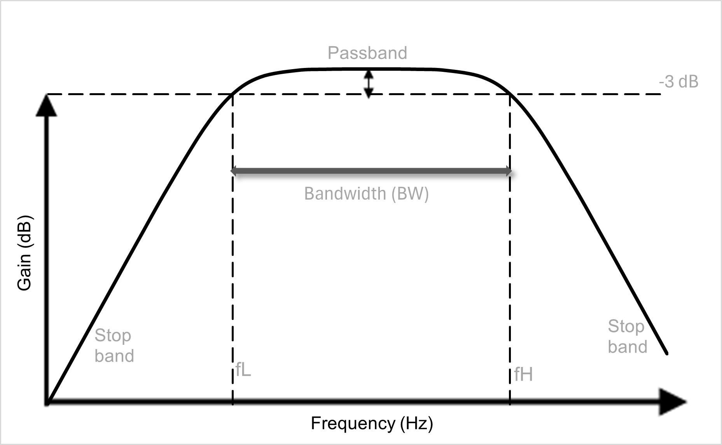
Figure 1: Frequency response of an ideal band-pass filter [3], [4].
A passive band-pass filter may be constructed using resistors and capacitors alone, without the need for an active component such as an operational amplifier. However, passive filters attenuate the signal within the passband as well as outside it, resulting in a voltage gain of less than unity [3]. In contrast, an active band-pass filter incorporates an operational amplifier, which provides gain within the passband, compensating for any attenuation introduced by the resistor-capacitor network and allowing the overall voltage gain to be set to a value greater than unity [6]. The operational amplifier also provides a low output impedance, which isolates the filter from the impedance of the load and prevents the load from affecting the filter's frequency response [4].
The operational amplifier is described by Storey as a device with very high open-loop voltage gain, very high input impedance and incredibly low output impedance, properties which make it well suited to active filter applications [3]. When negative feedback is applied, the closed-loop gain and frequency response of the circuit are determined primarily by the external components rather than by the characteristics of the operational amplifier itself, provided the open-loop gain of the device is sufficiently large [3].
The lower cut-off frequency of an active band-pass filter is determined by a high-pass resistor-capacitor network at the input of the operational amplifier. The lower cut-off frequency is given by equation (2).
$f_{L}= \frac{1}{2πR_{1}C_{1} }$ (2)
where fL is the lower cut-off frequency in Hz, R1 is the input resistance in ohms and C1 is the input capacitance in farads.
The upper cut-off frequency is determined by a low-pass resistor-capacitor network in the feedback path of the operational amplifier and is given by equation (3).
$f_{H}= \frac{1}{2πR_{2}C_{2}}$ (3)
where fH is the upper cut-off frequency in Hz, R2 is the feedback resistance in ohms and C2 is the feedback capacitance in farads.
The voltage gain of the active band-pass filter in the passband is determined by the ratio of the feedback resistance to the input resistance and is given by equation (4).
$A_{v}= -\frac{R_{f}}{R_{i}}$ (4)
where Av is the voltage gain, Rf is the feedback resistance in ohms and Ri is the input resistance in ohms. The negative sign indicates that the output signal is inverted with respect to the input signal, a consequence of the inverting amplifier configuration [3]. In practice, the magnitude of the voltage gain is the quantity of interest for amplifier design purposes, and the inversion of the signal is accounted for in the overall system design. The circuit configuration of an active band-pass filter is shown in Figure 2.
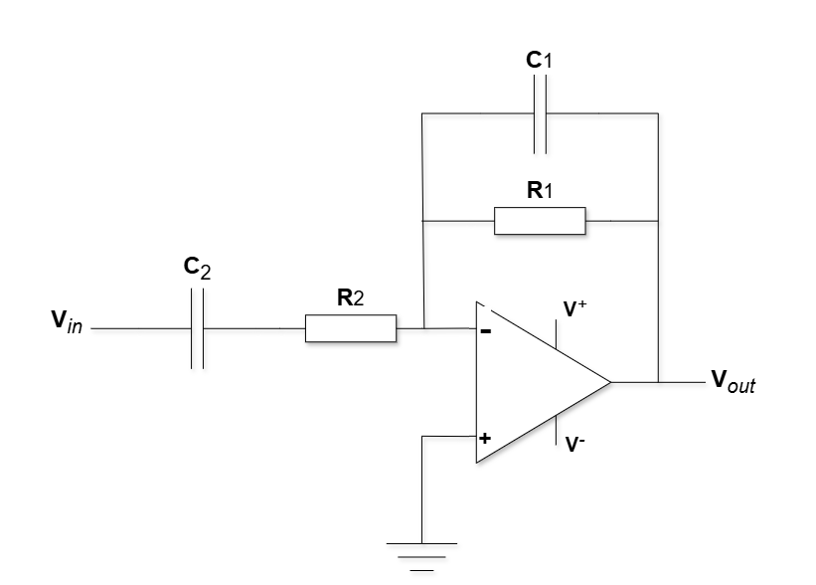
Figure 2: Active band-pass filter circuit [3], [4].
A comparison of the frequency responses of passive and active band-pass filters is shown in Figure 3.
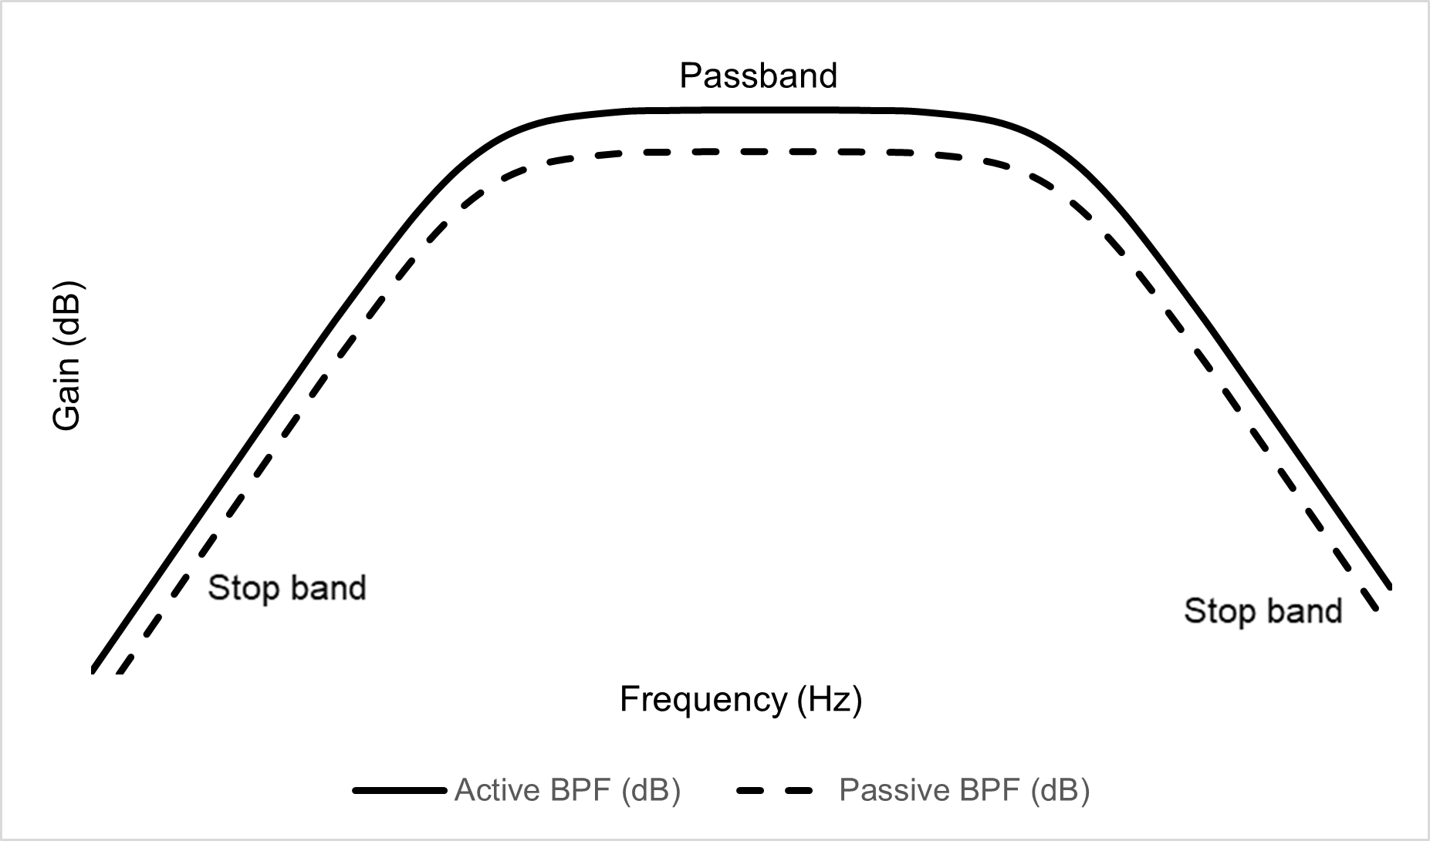
Figure 3: Comparison of passive and active band-pass filter frequency responses [3].

The TL071 Operational Amplifier
The TL071 is a general-purpose JFET-input operational amplifier manufactured by Texas Instruments [1]. The use of a junction field-effect transistor input stage provides a remarkably high input impedance and an extremely low input bias current, which minimises the loading effect on preceding signal sources and reduces offset errors in high-impedance circuit configurations [1]. The device is unity-gain stable, meaning that it may be operated with a closed-loop gain of unity without the risk of oscillation, which is an important characteristic for audio amplifier applications where a wide range of gain settings may be required [1].
The TL071 has a gain-bandwidth product of approximately 3 MHz, which defines the frequency up to which the device can provide useful amplification at a given closed-loop gain [1]. The slew rate of the device is 13 V/µs, which determines the maximum rate of change of the output voltage and sets an upper limit on the amplitude and frequency of signals that may be reproduced without distortion [1]. For a sinusoidal output signal, the maximum undistorted output frequency is determined by both the slew rate and the required output voltage swing. The device exhibits low input noise of 18 nV/√Hz and low total harmonic distortion of 0.003%, both of which are important parameters for high-fidelity audio reproduction [1]. The TL071 also incorporates internal output short-circuit protection, which prevents damage to the device in the event of an inadvertent short circuit at the output [1]. The device operates from a supply voltage range of ±2.25 V to ±18 V, making it suitable for use in both dual-supply and single-supply configurations [1]. The TL071 is a widely available, low-cost general-purpose device, which contributes to its suitability for high-volume audio and instrumentation applications [1].

The TL071 as an Inverting Summing Active Band-Pass Filter
The TL071 may be configured as an inverting summing amplifier by connecting multiple input signals to the inverting input terminal through separate input resistors of equal value [7]. In this configuration, the output voltage is proportional to the inverted sum of all input signals, weighted by the ratio of the feedback resistance to the respective input resistance [3]. This property is exploited in the present design to combine the left and right channels of a stereo audio signal into a single mono signal prior to filtering and amplification.
The frequency-selective behaviour of the active band-pass filter is achieved by incorporating a resistor-capacitor network at both the input and the feedback path of the operational amplifier [3]. A series resistor-capacitor network at the input acts as a high-pass filter, attenuating signals below the lower cut-off frequency fL as described by equation (2). A parallel resistor-capacitor network in the feedback path acts as a low-pass filter, attenuating signals above the upper cut-off frequency fH as described by equation (3). The combination of these two networks within a single inverting amplifier stage produces a band-pass frequency response, with voltage gain in the passband determined by equation (4) [7]. The circuit configuration of the TL071 connected as an inverting summing active band-pass filter is shown in Figure 2 [1], [7].

The OPA551 Operational Amplifier
The OPA551 is a high-voltage, high-current operational amplifier manufactured by Texas Instruments, designed specifically for applications requiring large output current capability [2]. Unlike general-purpose operational amplifiers, the OPA551 can supply a continuous output current of up to ±200 mA, which makes it suitable for directly driving low impedance loads such as loudspeakers without the need for an additional discrete output stage [2].
The OPA551 has a gain-bandwidth product of 3 MHz and a slew rate of ±15 V/µs, providing sufficient bandwidth and dynamic performance for audio frequency applications across the full audible range [2]. The device is unity-gain stable, meaning that it may be operated as a voltage follower with a closed-loop gain of unity without oscillation [2]. The OPA551 operates from a supply voltage range of ±4 V to ±30 V, making it compatible with both dual-supply and single-supply configurations [2]. The device also incorporates an internal current-limiting flag output, which provides a logic-level warning signal when the output current approaches its maximum rated value, offering a degree of protection for the load and the device itself [2]. The relatively wide supply voltage range and high output current capability distinguish the OPA551 from general-purpose devices such as the TL071 and make it well suited to the power amplifier stage of the two-stage audio amplifier described in this report [2]. The OPA551 commands a higher unit cost than general-purpose operational amplifiers because of its specialised high-current output stage, reflecting its suitability for demanding power amplifier applications [2].

The OPA551 as a Unity-Gain Voltage Follower
The OPA551 is connected in a unity-gain voltage follower configuration by connecting the output terminal directly to the inverting input terminal, with the input signal applied to the non-inverting input terminal [2]. In this configuration, the closed-loop voltage gain is unity, as expressed in equation (5).
$A_{v}=1$ (5)
where Av is the closed-loop voltage gain. The output voltage is therefore equal in magnitude and phase to the input voltage, and no voltage amplification is provided by this stage [3].
The purpose of the voltage follower configuration is not to provide voltage gain but to provide current gain. The TL071 active filter stage produces a voltage signal at the required amplitude and frequency response but is incapable of supplying the output current necessary to drive a low-impedance load such as an 8 Ω loudspeaker [1]. By buffering the output of the TL071 with the OPA551 voltage follower, the voltage signal is transferred to the load without attenuation whilst the OPA551 supplies the required output current from its own supply rails [2]. This configuration exploits the high output current capability of the OPA551, which can supply up to ±200 mA continuously, whilst preserving the frequency response and gain characteristics established by the TL071 filter stage [2], [7]. The pin configuration of the TL071 is shown in Figure 4 and the pin configuration of the OPA551 is shown in Figure 5.
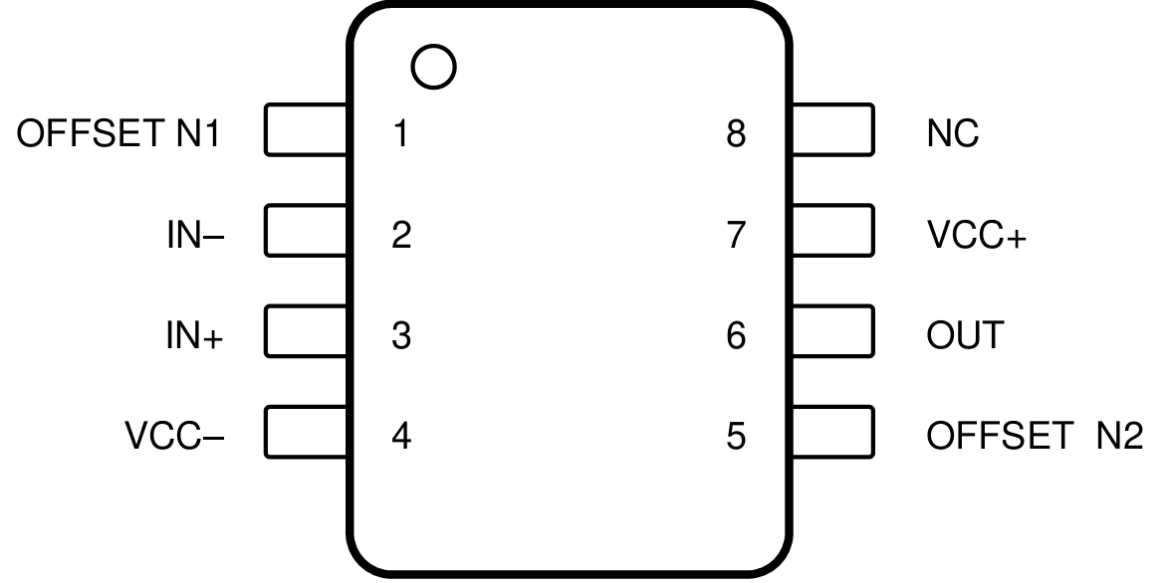  Figure 4: Pin configuration of the TL071 operational amplifier [1]. | 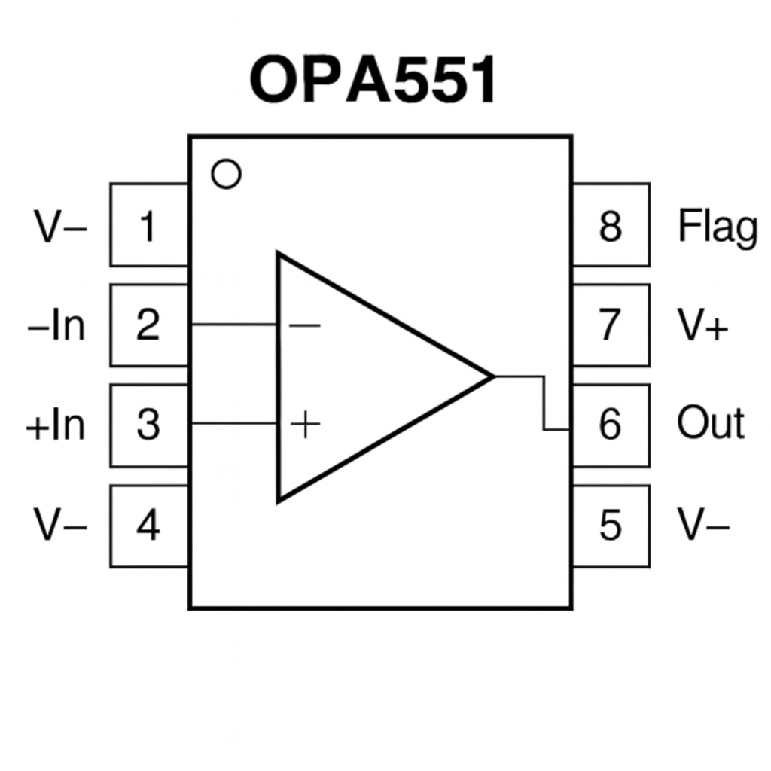  Figure 5: Pin configuration of the OPA551 operational amplifier [2].

The Two-Stage Amplifier Architecture
The two-stage amplifier architecture employed in this design arises from the differing electrical characteristics of the TL071 and OPA551 operational amplifiers. The TL071 is well suited to signal processing tasks such as filtering and gain setting due to its low noise, low distortion and JFET input stage, but its output current capability is limited to ±10 mA [1]. This is insufficient to drive a low-impedance load such as an 8 Ω loudspeaker at the required output voltage swing, as the current demand of such a load would exceed the output current rating of the device and result in signal clipping or device damage [3].
The OPA551 addresses this limitation by providing an output current capability of up to ±200 mA, which is sufficient to drive an 8 Ω load at the required output power [2]. However, the OPA551 does not offer the same low-noise, low-distortion signal processing characteristics as the TL071 and is not the optimum choice for the filtering and gain-setting stage [2]. Two TL071 devices could not be used in place of the two-stage architecture because the TL071 does not have sufficient output current capability to drive the speaker regardless of how it is configured [1]. By combining the TL071 as the signal processing stage with the OPA551 as the current amplification stage, the design exploits the complementary strengths of both devices [7].

Single-Supply Operation
Operational amplifiers are conventionally operated from a dual power supply, consisting of equal positive and negative supply voltages referenced to a common ground, which allows the output voltage to swing symmetrically about zero volts [3]. However, portable audio devices such as the one described in this report are powered from a single supply voltage, such as a 9 V battery, which does not provide a negative supply rail. Single-supply operation of an operational amplifier requires the establishment of a virtual ground reference at a voltage equal to half the supply voltage, commonly referred to as Vcc/2 [8]. This virtual ground is typically generated using a resistive voltage divider connected between the supply rail and ground, with a decoupling capacitor connected in parallel to present a low impedance at signal frequencies [8].
In single-supply operation, all signal voltages are referenced to the virtual ground rather than to the circuit ground, allowing the output to swing symmetrically about Vcc/2 [8]. AC coupling capacitors are placed at the input and output of the amplifier circuit to block the DC bias voltage from the signal source and the load respectively, ensuring that only the AC audio signal is passed between stages [3]. The input coupling capacitor also forms part of the high-pass filter network together with the input resistor, contributing to the determination of the lower cut-off frequency of the active band-pass filter [3], [9]. Without single-supply biasing and AC coupling, the DC operating point of the amplifier would be incompatible with a single supply voltage and correct signal amplification would not be achieved [8].

Design Description
This section presents the design description of the two-stage audio amplifier, detailing the technical specifications, design calculations and component-level circuit description. The section begins with a summary of the key electrical specifications in Table 1, followed by an overview of the system architecture. Full design calculations are then presented, including the derivation of the voltage gain, lower cut-off frequency and upper cut-off frequency from the measured input characteristics of the source device. A detailed description of each stage of the circuit is subsequently provided, with reference to specific component designators, followed by a description of the PCB design and three-dimensional mechanical model.

Technical specifications
Table 1: Electrical specifications of the two-stage audio amplifier.
Electrical Characteristic | Value | Notes
Input signal | 0.872 Vpp | iPhone 14 Pro Max, volume step 15 of 16 at 440 Hz, 70% of maximum output
Supply voltage | 9 V or 12 V | 9 V PP3 battery via battery connector or 12 V DC adapter via barrel jack
Lower cut-off frequency | Target: 5 Hz / Actual: 6.63 Hz | FL = 5 Hz was a given fixed value. Actual value limited by available stock capacitor, C2 = 1 µF
Upper cut-off frequency | Target: 29 kHz / Actual: 28.54 kHz | fu chosen within allowed range (22–46 kHz). Actual value limited by available stock capacitor, C1 = 68 pF
Measured gain | Target: 10.73 dB / Actual: 10.67 dB  Voltage gain ratio: 3.42 V/V | R1 = 82 kΩ was a given fixed value. R2 calculated then limited by available stock resistor, R2 = 24 kΩ
Target output voltage | 3 Vpp | Across 8 Ω speaker load
Output power of power  amplifier | 281 mW | P = Vpp² / (8 × R) = 9 / 64 = 0.281 W [3] (Storey)
Resistance of speaker | 8 Ω | Speaker impedance varies with frequency; it has therefore been approximated.
Maximum output current of  power amplifier | ±200 mA | The OPA551 is rated for a continuous output current of up to ±200 mA, sufficient to drive an 8 Ω loudspeaker load at the required output voltage [2].
Maximum output voltage of  power amplifier | 3 Vpp / 6 Vpp (usable symmetrical swing about 4.5 V virtual ground) | On a 9 V supply, the usable output swing is approximately 3 V to 6 V, centred at the 4.5 V virtual ground, ensuring the 3 Vpp design target remains within the allowable limits. Values are approximate and vary with load current and thermal conditions [2].
Key ICs | TL071, OPA551 | Stage 1: TL071 active filter [1]. Stage 2: OPA551 unity-gain buffer [2].
Controls
Volume control | iPhone 14 Pro max (built in volume control) | The iPhone 14 Pro Max integrated volume control adjusts the input signal amplitude directly, eliminating the requirement for a hardware potentiometer on the PCB.
Indicators
On/off switch | Yes, Passive | A passive SPST slide switch on the power supply rail controls power delivery to the circuit.
LED indicator | Yes, Active (Green LED) | A green LED provides visual indication of power status. Series current-limiting resistor R6 restricts the forward current to a safe operating level.
Mechanical
PCB dimensions | 65 mm × 40 mm | Two-layer PCB designed in Proteus
Enclosure | Acrylic mounting plate | 65 mm × 40 mm with speaker grille aperture
PCB mounting | M3 nylon hex standoffs | M3 20 mm screws, M3 6 mm nuts and washers

Full design calculations supporting the values presented in Table 1 are provided in Section 3.3.

Overview of the design
The overall architecture of the two-stage audio amplifier is presented in Figure 6. The system accepts a stereo audio input signal from a 3.5 mm jack socket connected to an iPhone 14 Pro Max and produces a mono amplified output suitable for driving an 8 Ω speaker load. The mobile phone and speaker are external to the amplifier system. Power is supplied from the top of the system via either a 9 V PP3 battery or a 12 V DC power adapter, passing through an on/off slide switch and a green power indicator LED before being distributed to the two amplifier stages.The first stage is implemented using a TL071 operational amplifier configured as an inverting summing active band-pass filter. This stage combines the left and right stereo input channels into a single mono signal, applies voltage gain and restricts the passband to the desired frequency range. The filtered and amplified signal is passed to the second stage, implemented using an OPA551 operational amplifier configured as a unity-gain voltage follower. The function of the second stage is not to provide additional voltage gain but to provide the current drive capability necessary to deliver 3 Vpp across the 8 Ω speaker load. The signal flow is left to right, with the input on the left and the speaker output on the right. Power is distributed top to bottom, from the power input block through the on/off switch to both amplifier stages, consistent with standard block diagram convention [10].
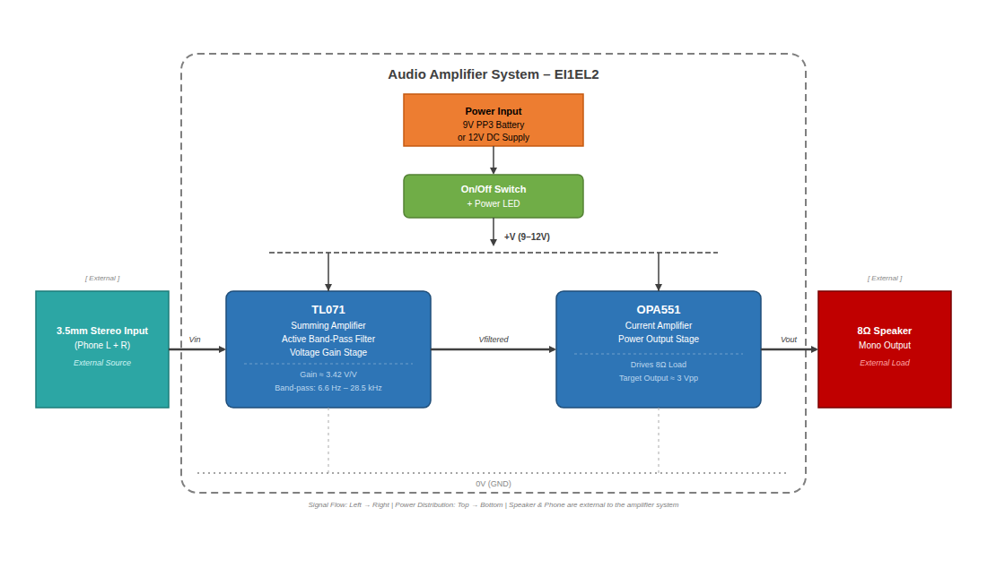
Figure 6: Top-level block diagram of the two-stage audio amplifier system.

Design calculations
The iPhone 14 Pro Max was characterised by measuring the output voltage at 440 Hz across all 16 volume steps. A frequency of 440 Hz was selected, and it corresponds to the international standard musical pitch A4 providing a consistent and reproducible test signal [3]. The measured output voltage at each step is presented in Figure 7. The design input level was selected at 70% of the maximum measured output of 1.224 Vpp, giving a target of 0.857 Vpp. Volume step 15 of 16 produced an output of 0.872 Vpp, representing an error of 1.77% from the 70% target. This value was therefore adopted as the design input voltage. This analysis confirms that the amplifier design can support the full voltage range produced by the mobile phone without signal clipping or distortion which validates that the chosen gain results in the intended output voltage of approximately 3 Vpp under normal listening conditions. A graph of Vpp (V) vs volume step was produced in Excel using the converted voltage values. The following were included to make the chosen operating point clear. A horizontal 70% target reference broken line in red at 0.8568 V, A labelled marker at the chosen design point (Step 15, 0.872 V). The phone volume steps are not linear, so voltage increases slowly at low steps and rises sharply at higher steps. Also, because of discrete volume steps, the 70% point cannot be matched exactly so the closest step was chosen and the resulting error was quantified. Excel formulas were used throughout to ensure the sheet remains robust and updates automatically if any measurements are revised.
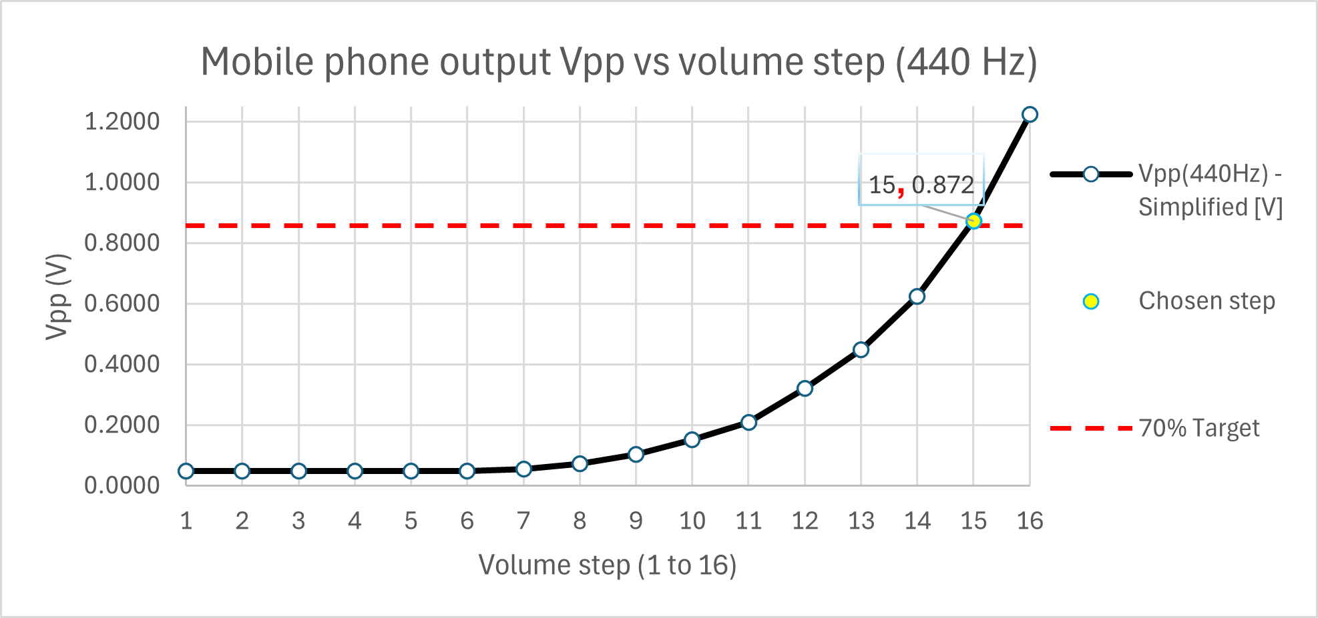
Figure 7: iPhone 14 Pro Max output voltage versus volume step at 440 Hz.
The target output voltage was specified as 3 Vpp across the 8 Ω speaker load. An output of 3 Vpp was selected as it represents a suitable listening level whilst remaining within the usable output swing of the OPA551 on a 9 V single supply [2]. The required voltage gain was calculated using equation (6) [13].
$A_{v}= \frac{V_{out}}{V_{in}}=\frac{3}{0.872}=3.44 \text{V/V }$ (6)
where Av is the voltage gain, Vout is the target output voltage in volts and Vin is the design input voltage in volts. Converting to decibels using equation (7):
$A_{v}\left(\text{dB}\right)=20×\log_{10}\left(3.44\right)=10.73 \text{dB}$ (7)
The feedback resistor R1 was given as a fixed value of 82 kΩ. The required input resistor R2 was calculated using equation (8), derived from equation (4).
$R_{2}=\frac{R_{1}}{A_{v}}=\frac{82000}{3.44}=23.84 \text{kΩ}$ (8)
where R2 is the input resistance in ohms and R1 is the feedback resistance in ohms. The nearest preferred stock value of 24 kΩ was selected for R2, giving an actual gain as shown in equation (9).
$A_{v}\text{(actual) }=\frac{R_{1}}{R_{2}}=\frac{82000}{24000}=3.42 \text{V/V = 10.67 dB}$ (9)
where Av(actual) is the actual voltage gain, R1 is the feedback resistance in ohms and R2 is the input resistance in ohms. The selected resistors R1 and R2 carry a tolerance of ±1%, meaning the actual gain may vary between 3.39 V/V and 3.46 V/V, corresponding to a worst-case range of 10.60 dB to 10.78 dB, within which all measured values fall [13]. The lower cut-off frequency fL was given as a fixed value of 5 Hz. Rearranging equation (2), the required capacitance C2 was calculated as shown in equation (10).
$C_{2}=\frac{1}{\begin{aligned}2π×R_{2}×f_{L} \\ \end{aligned}}= \frac{1}{2π×24000×5}=1.326\text{ µF}$ (10)
where C2 is the capacitance in farads, R2 is the input resistance in ohms and fL is the lower cut-off frequency in Hz. The nearest preferred stock value of 1 µF was selected for C2, giving an actual lower cut-off frequency as shown in equation (11).
$f_{L}\text{ (actual)}=\frac{1}{2π×R_{2}×C_{2}}= \frac{1}{2π×24000×{1×10}^{-6}}=\text{ 6.63 Hz}$ (11)
where fL(actual) is the actual lower cut-off frequency in Hz, R2 is the input resistance in ohms and C2 is the input capacitance in farads. The upper cut-off frequency fH was selected as 29 kHz, within the permitted design range. Rearranging equation (3), the required capacitance C1 was calculated as shown in equation (12).

$C_{1}=\frac{1}{2π×R_{1}×f_{H}}= \frac{1}{2π×82000×29000}=66.93 \text{pF}$ (12)
where C1 is the feedback capacitance in farads, R1 is the feedback resistance in ohms and fH is the upper cut-off frequency in Hz. The nearest preferred stock value of 68 pF was selected for C1, giving an actual upper cut-off frequency as shown in equation (13).
$f_{H}\text{ (actual)}=\frac{1}{2π×R_{1}×C_{1}}= \frac{1}{2π×82000×68 ×{10}^{-12}}=\text{ 28,542 Hz}$ (13)
where fH(actual) is the actual upper cut-off frequency in Hz, R1 is the feedback resistance in ohms and C1 is the feedback capacitance in farads. The output power delivered to the speaker load was calculated using equation (14).
$\text{P = }\frac{V_{{pp}^{2}}}{8×\text{R}}=\frac{9}{8×8}=0.281 \text{W}=281\text{ mW}$ (14)
where P is the output power in watts, Vpp is the peak-to-peak output voltage in volts and R is the load resistance in ohms [3]. The current-limiting resistor R6 for the power indicator LED D1 was calculated using equation (15).
$R_{6}=\frac{V_{s}-V_{f}}{I_{f} }=\frac{12-2.1}{0.003}=\frac{9.9}{0.003}= 3300 \text{Ω}$ (15)
where R6 is the current-limiting resistance in ohms, Vs is the supply voltage in volts, Vf is the LED forward voltage in volts and if is the LED forward current in amperes. A supply voltage of 12 V was used to ensure safe operation under worst-case conditions. A forward voltage of 2.1 V was assumed for the green LED D1. The nearest preferred stock value of 3.3 kΩ was selected for R6, providing an operating current of approximately 3 mA.

Detailed description
This section presents a component-level description of the complete circuit. The full circuit schematic is provided in Appendix B, and the following description refers to the circuit as shown in Figure 8 and Figure 9.
The first stage is implemented using U1, a TL071CP configured as an inverting summing active band-pass filter, as shown in Figure 8. The audio signal from the iPhone 14 Pro Max is connected via the 3.5 mm stereo jack socket J1. The left channel passes through C2 of 1 µF and R2 of 24 kΩ in series, whilst the right channel passes through C6 of 1 µF and R5 of 24 kΩ in series, both connecting to the inverting input of U1 to sum the stereo channels into a mono signal. Feedback resistor R1 of 82 kΩ is connected between output pin 6 and inverting input pin 2 of U1, with the voltage gain determined by the ratio of R1 to R2 as shown in equation (9), giving 3.42 V/V or 10.67 dB. Capacitor C1 of 68 pF is connected in parallel with R1, with the upper cut-off frequency determined by R1 and C1 as calculated in equation (13), giving fH = 28,542 Hz. The lower cut-off frequency is determined by R2 and C2 as calculated in equation (11), giving fL = 6.63 Hz. C2 and C6 are polyester film capacitors, selected for their non-polarised construction and superior stability compared to electrolytic types for AC coupling [3].
Single-supply operation is achieved by biasing pin 3 of U1 to half the supply voltage via the potential divider formed by R3 and R4, each of 24 kΩ, giving approximately 4.5 V on a 9 V supply. This mid-supply potential allows the output to swing symmetrically without clipping. Without single-supply biasing, negative half-cycles would be clipped as the output cannot swing below 0 V [8].
Power supply decoupling capacitors prevent high-frequency noise from coupling into the signal path [7]. C3 and C4, each 100 nF ceramic, are placed close to the supply pins of U1, and C7 of 100 nF provides equivalent decoupling at U2. C5 of 10 µF is an electrolytic bulk decoupling capacitor at U2, suppressing lower-frequency noise and providing a local charge reservoir for the transient current demands of the OPA551PA [2], as shown in Figure 8 and Figure 9.

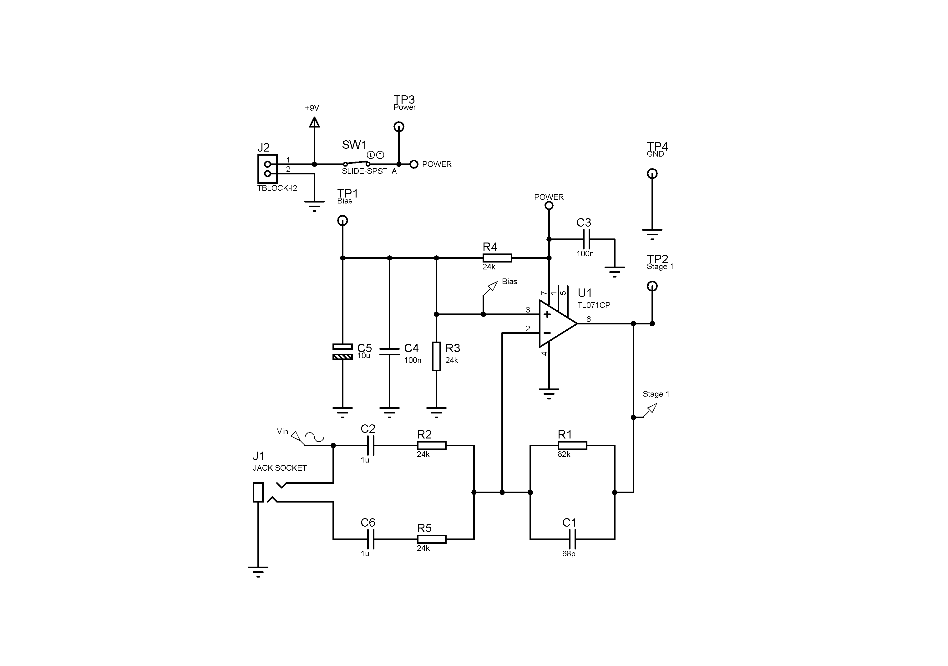  Figure 8: TL071CP active band-pass filter stage sub-circuit. | 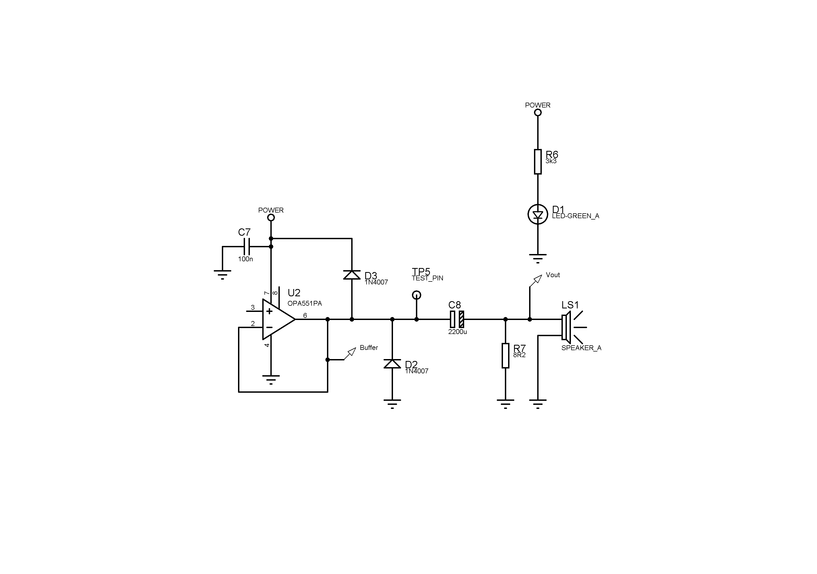  Figure 9: OPA551PA unity-gain buffer output stage sub-circuit.

The input network to U1 uses two parallel signal paths, one for each stereo channel. The left channel path comprises capacitor C2 of 1 µF in series with resistor R2 of 24 kΩ, and the right channel path comprises capacitor C6 of 1 µF in series with resistor R5 of 24 kΩ. The matched 24 kΩ resistors ensure both channels present identical input impedance and contribute equal gain to the summed mono output. The series capacitors C2 and C6 also serve to AC-couple the input signal, blocking any DC component present on the audio output of the iPhone 14 Pro Max and preventing it from disturbing the bias conditions at the inverting input of U1 [3]. Diodes D2 and D3, both 1N4007 silicon rectifier diodes, are included to provide protection against reverse polarity connection of the power supply. The 1N4007 is rated for a peak inverse voltage of 1000 V and a forward current of 1 A, providing robust protection for both integrated circuits [4], [5]. D3 is connected in series with the positive supply rail between the power input and the supply pin of U2, becoming reverse biased under reversed polarity and blocking current flow to prevent damage. D2 is connected between the output of U2 and ground, clamping any negative voltage spike at the output to approximately −0.7 V and protecting the output stage from reverse voltage transients.
Capacitor C8 of 2200 µF is connected in series between the output of U2 at pin 6 and the speaker output terminal LS1. The output of U2 sits at approximately half the supply voltage due to single-supply biasing, which would impose a large DC current through the speaker load if C8 were not present, wasting power and potentially damaging the voice coil. C8 therefore serves as a DC-blocking capacitor, passing only the AC audio signal to the speaker. Together with the 8 Ω speaker load, C8 forms a high-pass RC filter with a cut-off frequency calculated as shown in equation (16).
$fC=\frac{1}{2π×C_{8}×RL}=\frac{1}{2π×2200×{10}^{-6}×8}=9.05 \text{Hz}$ (16)
where fC is the cut-off frequency of the output RC network in Hz, C8 is the output coupling capacitance in farads and RL is the speaker load resistance in ohms. A value of 2200 µF was selected such that the calculated cut-off frequency of 9.05 Hz is sufficiently low to ensure that C8 does not restrict the amplifier passband. As the active filter already attenuates signals below 6.63 Hz, the additional high-pass effect of C8 and the speaker load does not affect audible performance within the intended passband.
In the Proteus simulation environment, the loudspeaker LS1 is replaced by a fixed resistor R7 of 8.2 Ω as the simulation load, as Proteus does not accurately model the frequency-dependent impedance of a real loudspeaker. R7 presents a constant 8.2 Ω resistive load at all frequencies, ensuring that the simulated frequency response reflects the behaviour of the amplifier circuit alone. The value of 8.2 Ω was selected as the nearest standard resistor value to the nominal 8 Ω speaker impedance. On the physical breadboard prototype and the PCB, the actual 8 Ω loudspeaker LS1 is connected as the output load via terminal block J2.
The green power indicator LED D1 is connected in series with current-limiting resistor R6 of 3.3 kΩ between the positive supply rail and 0 V. When power is applied and SW1 is closed, current flows through R6 and D1, providing visual indication that the amplifier is powered. The value of R6 was calculated using the worst-case supply voltage of 12 V and a forward voltage of 2.1 V for D1, as shown in equation (15), giving a forward current of approximately 3 mA.

PCB design
The printed circuit board was designed in Proteus PCB Layout with overall dimensions of 65 mm × 40 mm, as shown in Figure 10. Component placement followed the principle of signal flow from left to right, with the audio input jack socket J1 positioned on the left edge, the power supply terminal block J2 on the top right edge and the speaker output LS1 on the bottom right edge. The power switch SW1 and LED indicator D1 with current-limiting resistor R6 are positioned along the top edge for easy user access and clear visual indication of power status. All connectors and terminals are positioned at the board edges to ensure cables and wires can be inserted easily during assembly and testing. The two integrated circuits U1 and U2 are placed centrally on the board, with U1 positioned to the left of U2 in accordance with the signal flow direction. Decoupling capacitor C3 of 100 nF is placed between U1 and U2, positioned close to the supply pin of U1, and decoupling capacitor C7 of 100 nF is placed immediately adjacent to the supply pin of U2. This short connection is essential for effective suppression of high-frequency noise, as any additional track length introduces parasitic inductance that reduces decoupling effectiveness [7]. The single-supply bias network, comprising resistors R3 and R4 and capacitors C4 and C5, is positioned to the left of U1. The large output coupling capacitor C8 of 2200 µF is positioned in the lower right area of the board due to its physical size. Signal tracks were routed at a width of T30 (0.762 mm) and power supply tracks at T40 (1.016 mm) to accommodate higher supply rail currents and reduce resistive voltage drop. Wider power tracks also improve mechanical durability during etching, as thinner tracks are more susceptible to over-etching and hairline cracks [6]. Track junctions were routed using mitred corners rather than 90° bends wherever possible, as sharp corners concentrate current density and radiate electromagnetic energy that can introduce interference into sensitive signal tracks [6]. A copper pour was applied to the bottom layer to form a continuous ground plane, as shown in Figure 11, reducing ground return impedance, minimising noise coupling between stages and improving electromagnetic compatibility. A minimum clearance of 20th (0.508 mm) was applied between all pads, traces and the board edge as defined in the DEFAULT design rule set. The PCB design was verified using the Proteus Design Rule Check, which returned no DRC errors. The student number 240191278 is included as text on the bottom copper layer to identify the board after etching.
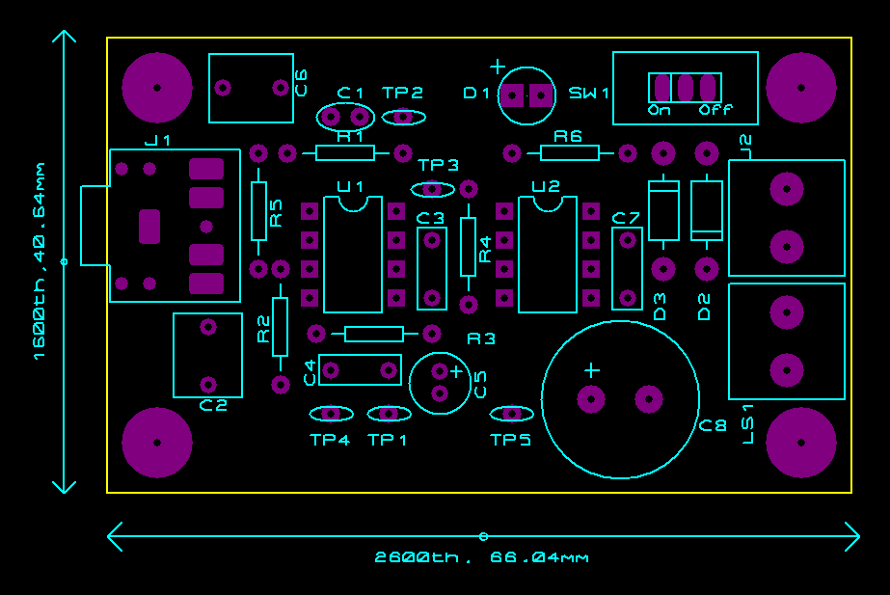  Figure 10: PCB top layer showing component placement and silk screen. | 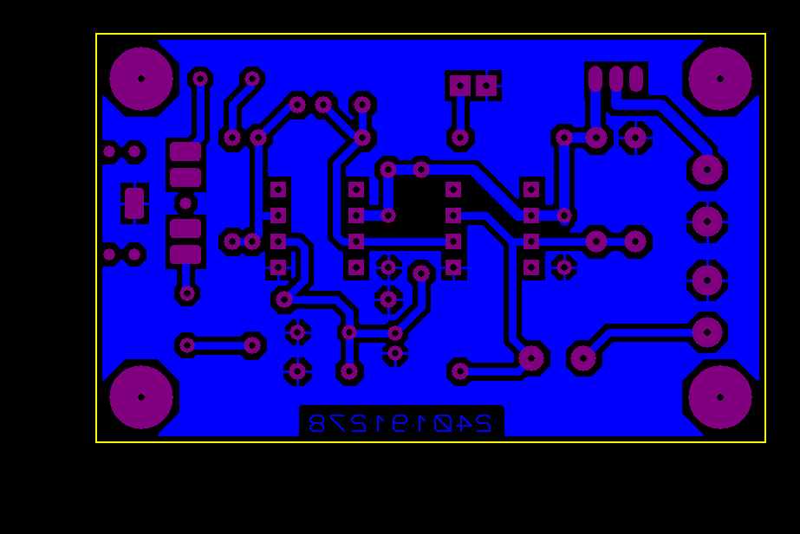  Figure 11: PCB bottom layer showing copper track routing and ground plane.

3D Model from Proteus
A three-dimensional visualisation of the PCB was generated using the Proteus 3D Visualiser, as shown in Figure 12. The model confirms that all through-hole components are correctly orientated, with U1 and U2 positioned centrally as dual in-line packages. The electrolytic capacitors C5 and C8 are clearly visible due to their physical height; C8 of 2200 µF is the tallest component and its height must be considered when fitting the PCB within the intended enclosure. The four mounting holes at the corners allow the PCB to be secured to the acrylic base plate using M3 screws and spacers.
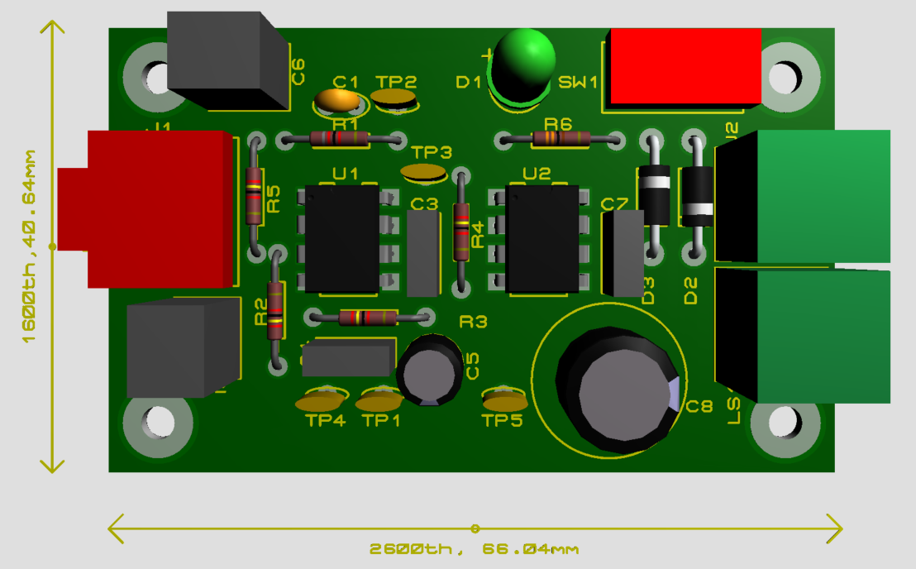
Figure 12: Three-dimensional model of the PCB.

Results
This section presents the results obtained from simulation and experimental testing of the two-stage audio amplifier. Section 4.1 presents the breadboard testing results, Section 4.2 presents the PCB testing results including frequency response graphs, a summary comparison table and time-domain waveforms at 440 Hz, Section 4.3 presents photographs of the final assembled board and Section 4.4 provides an evaluation against the original specification. All frequency response measurements were performed using a function generator and a two-channel digital oscilloscope set to DC coupling throughout. The input signal was maintained at approximately 0.872 Vpp and the gain at each frequency was calculated from the ratio of output to input peak-to-peak voltages and expressed in decibels. For the dual-supply breadboard measurement, the first stage was powered from a dual ±9 V laboratory power supply with the output measured directly at pin 6 of U1, with no DC offset present. For the single-supply breadboard and PCB stage 1 measurements, a 470 nF external capacitor was connected in series between the output of U1 and the oscilloscope to remove the 4.5 V DC offset, forming a high-pass network with a cut-off frequency of approximately 0.34 Hz. For the PCB stage 2 measurement, load resistor R7 of 8.2 Ω was connected at the output and no external coupling capacitor was required as C8 of 2200 µF blocks the DC offset internally.

Prototype testing and results.
The frequency response of the first amplifier stage was measured on breadboard with a dual ±9 V power supply, with the output measured at pin 6 of U1. The simulated and measured results are shown in Figure 13. The simulated and measured midband gain at 440 Hz were both 10.67 dB, demonstrating exact agreement. The simulated lower cut-off frequency was 6.6 Hz, and the measured value was approximately 7.2 Hz, in close agreement with the calculated value of 6.63 Hz. The simulated upper cut-off frequency was 27.7 kHz, and the measured value was approximately 26.0 kHz. The small discrepancy between simulated and measured cut-off frequencies is attributable to component tolerances, as standard resistors and capacitors can exhibit tolerances of up to ±20%. The 440 Hz operating point is identified on Figure 13 by a red data label.
Figure 14 shows the simulated and measured frequency response of the complete amplifier on breadboard with a single 9 V power supply, with the output measured at pin 6 of U1 via the 470 nF external coupling capacitor described in Section 4. The measured midband gain at 440 Hz was 10.78 dB, in close agreement with the calculated value of 10.67 dB, with the small difference within the tolerance of the selected resistor values. The measured lower cut-off frequency was approximately 6.8 Hz, consistent with both the calculated value of 6.63 Hz and the dual-supply breadboard result. The measured upper cut-off frequency was approximately 27.1 kHz, consistent with the upper cut-off determined by C1 of 68 pF. The 440 Hz operating point is identified on Figure 14 by a red data label.
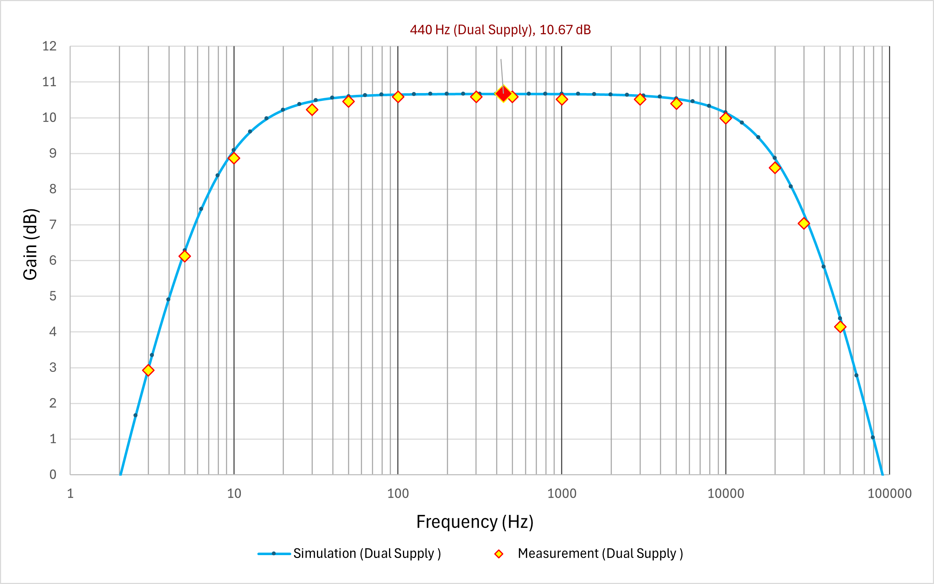
Figure 13: Simulated and measured frequency response of the first amplifier stage on breadboard with dual ±9 V power supply.
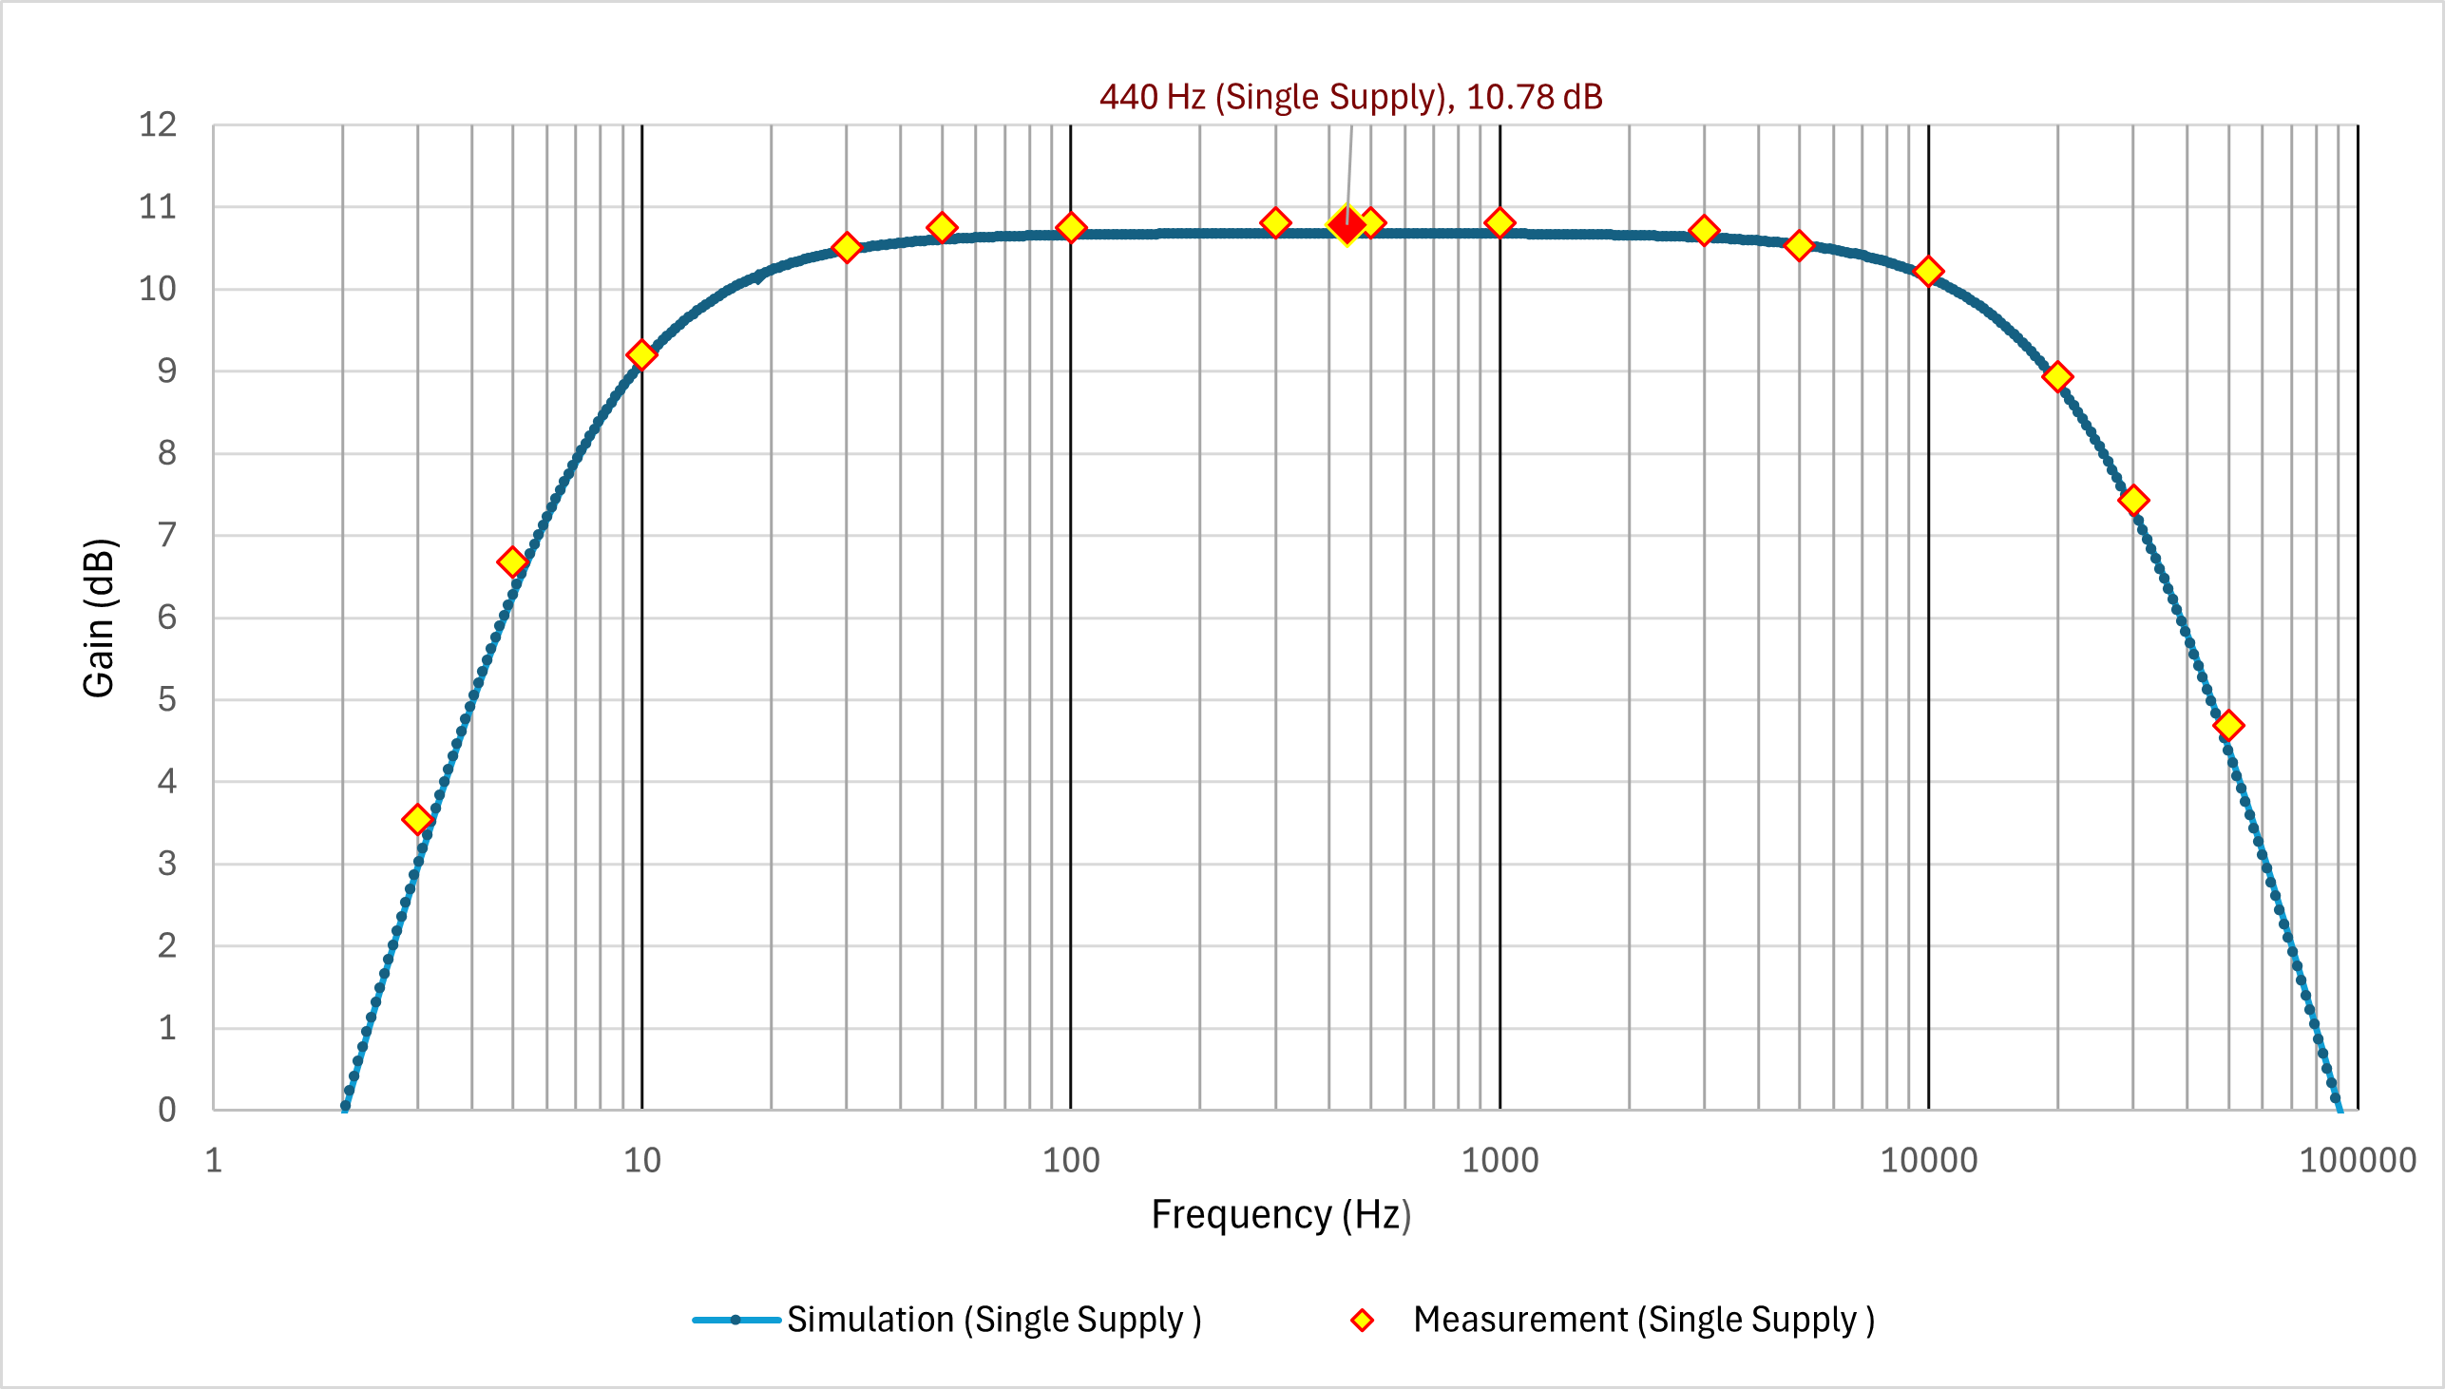
Figure 14: Simulated and measured frequency response of the complete two-stage amplifier on breadboard with single 9 V power supply.

PCB testing and results
The PCB was tested in two stages. Prior to fitting any integrated circuits, a multimeter was used to confirm that the virtual ground bias voltage of approximately 4.5 V was present at the non-inverting input pin 3 of U1. U1 was then fitted and a full frequency sweep from 1 Hz to 100 kHz was performed at the stage 1 output at pin 6 of U1, with the input maintained at 0.872 Vpp and a 470 nF external capacitor connected in series to remove the DC offset, as described in Section 4. U2 was then fitted without load resistor R7, and the 440 Hz output was verified at 3 Vpp with no clipping observed. Load resistor R7 of 8.2 Ω was then connected at the output and a second full frequency sweep from 1 Hz to 100 kHz was performed at the stage 2 output. The output coupling capacitor C8 of 2200 µF blocks the DC offset from the stage 2 output, so no additional external coupling capacitor was required. The simulated and measured results for both stages are shown in Figure 15.
The simulated midband gain of stage 1 was 10.67 dB and the measured midband gain at 440 Hz was 10.77 dB, demonstrating close agreement. The simulated and measured midband gain of stage 2 were both 10.67 dB, confirming that U2 introduces no additional voltage gain as designed. The simulated lower cut-off frequency of stage 1 was 6.65 Hz, and the measured value was approximately 6.9 Hz, representing the closest agreement with the calculated value of 6.63 Hz across all test conditions. The simulated lower cut-off frequency of stage 2 was 12.08 Hz, and the measured value was approximately 13.2 Hz, consistent with the additional high-pass pole introduced by C8 in series with load resistor R7 of 8.2 Ω. The simulated upper cut-off frequency was 27.70 kHz for both stages, with measured values of approximately 29.5 kHz for stage 1 and approximately 30.0 kHz for stage 2, the small upward shift being attributable to the negative tolerance of C1 of 68 pF. The 440 Hz operating points for both stages are identified on Figure 15 by filled black markers.
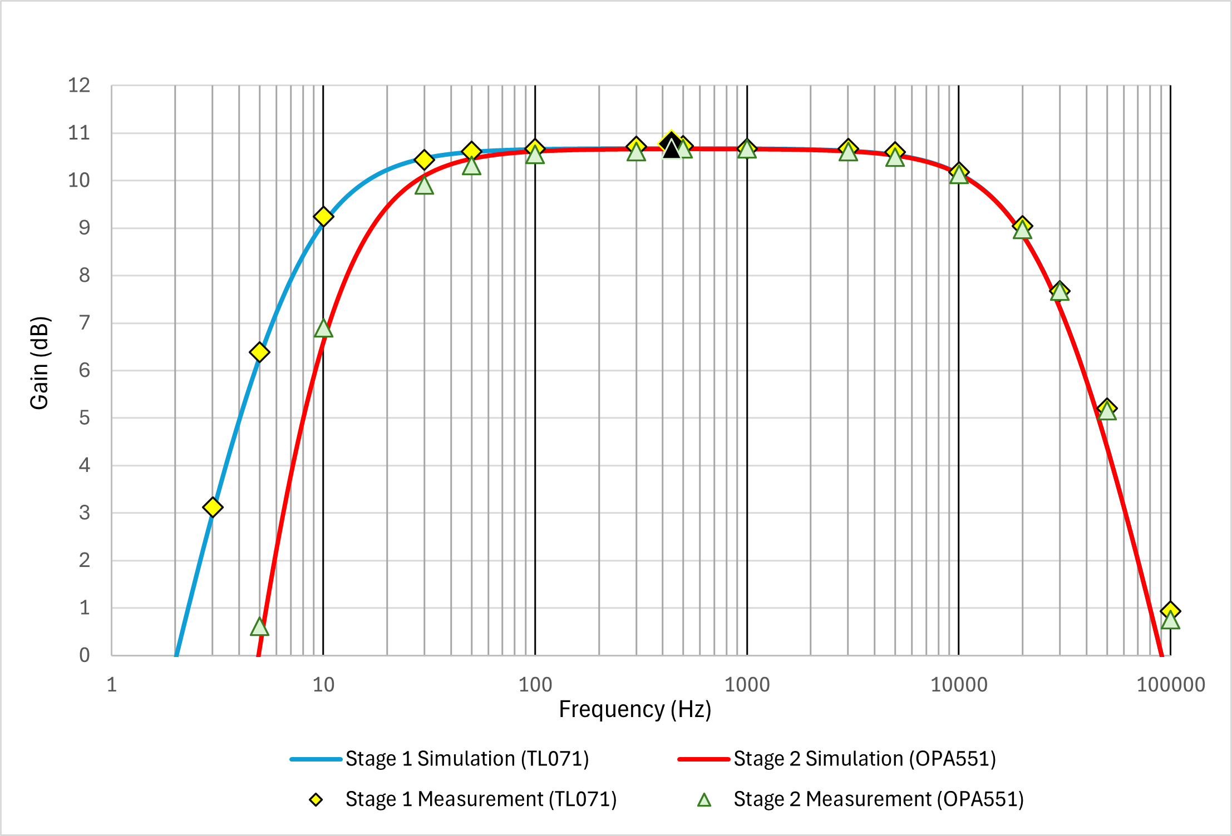
Figure 15: Simulated and measured frequency response of the complete two-stage amplifier on the printed circuit board.

Table 2 summarises the key performance parameters of the amplifier across all test conditions, comparing the calculated, simulated and measured values for midband gain, lower cut-off frequency, upper cut-off frequency and bandwidth.
Table 2: Comparison of calculated, simulated and measured amplifier performance parameters across all test conditions.
Parameter | Calculation | Simulation | Dual Supply BB | Single Supply BB | PCB Stage 1 | PCB Stage 2
Gain (dB) | 10.67 | 10.67 | ≈ 10.58 | ≈ 10.81 | ≈ 10.73 | 10.67
Lower cut-off frequency (Hz) | 6.63 | 6.60 | ≈ 7.2 | ≈ 6.8 | ≈ 6.9 | ≈ 13.2
Upper cut-off frequency (kHz) | 28.54 | 27.7 | ≈ 26.0 | ≈ 27.1 | ≈ 29.5 | ≈ 30.0
Bandwidth (kHz) | 28.53 | 27.7 | ≈ 26.0 | ≈ 27.1 | ≈ 29.5 | ≈ 30.0
The midband gain results show excellent consistency across all test conditions, with all measured values within 0.14 dB of the calculated value of 10.67 dB. The lower cut-off frequency shows close agreement with the calculated value of 6.63 Hz across most conditions, with minor differences attributable to component tolerances of up to ±20%. The PCB stage 1 lower cut-off of approximately 6.9 Hz represents the closest agreement across all conditions, consistent with the more precise component values achieved through soldered PCB assembly. The PCB stage 2 lower cut-off of approximately 13.2 Hz is higher than the design value, as expected given the additional high-pass pole introduced by C8 of 2200 µF in series with load resistor R7 of 8.2 Ω. The upper cut-off frequency shows good agreement across all conditions, with all measured values within 2.3 kHz of the simulated value of 27.70 kHz, the small upward shift being consistent with the negative tolerance of C1 of 68 pF. The bandwidth values follow directly from the upper and lower cut-off frequencies and show corresponding agreement across all conditions.
The time-domain response of the amplifier at 440 Hz was investigated through both simulation and experimental measurement to verify the output voltage and confirm the absence of signal distortion at the design operating frequency. The results are presented in Figure 16.
Figure 16(a) presents the Proteus transient simulation showing all four signal nodes simultaneously. Vin is displayed in green at 0.872 Vpp, centred at 0 V. The Stage 1 output at pin 6 of U1 is displayed in red and is coincident with the Buffer trace, as U2 is configured as a unity-gain voltage follower. The Buffer output at pin 6 of U2 is displayed in blue at approximately 3 Vpp, centred at the 4.5 V bias point established by R3 and R4. Vout, measured after DC-blocking capacitor C8, is displayed in yellow at approximately 3 Vpp, centred at 0 V. All waveforms are undistorted and symmetrical, confirming that U1 operates within its linear region under the specified input conditions.
Figure 16(b) presents the Proteus transient simulation for the final output, measured after C8. Vin is shown in red at 0.872 Vpp and Vout is shown in green at approximately 3 Vpp, centred at 0 V, confirming that C8 performs its intended DC-blocking function. A phase inversion of 180° is observable between Vin and Vout, consistent with the inverting amplifier topology of U1. The experimental results are presented in Figures 16(c) and 16(d). In Figure 16(c), CH1 (yellow) records an input of 868 mVpp at 440 Hz and CH2 (cyan) records a Stage 1 output of 3.000 Vpp, measured via a 470 nF external coupling capacitor connected to test point TP2. The measured voltage gain at Stage 1 is therefore 3.000 / 0.868 = 3.456, equivalent to 10.77 dB, in close agreement with the values presented in Table 2. In Figure 16(d), CH1 (yellow) records an input of 872 mVpp and CH2 (cyan) records a Stage 2 output of 2.980 Vpp, measured directly at the output terminal as C8 removes the DC offset internally. The voltage gain at Stage 2 is therefore 2.980 / 0.872 = 3.418, equivalent to 10.67 dB, in exact agreement with the calculated and simulated values. All four waveforms are clean, undistorted sinusoids at 440 Hz, confirming that both stages operate within their linear range and that the 3 Vpp output voltage target is met.
16a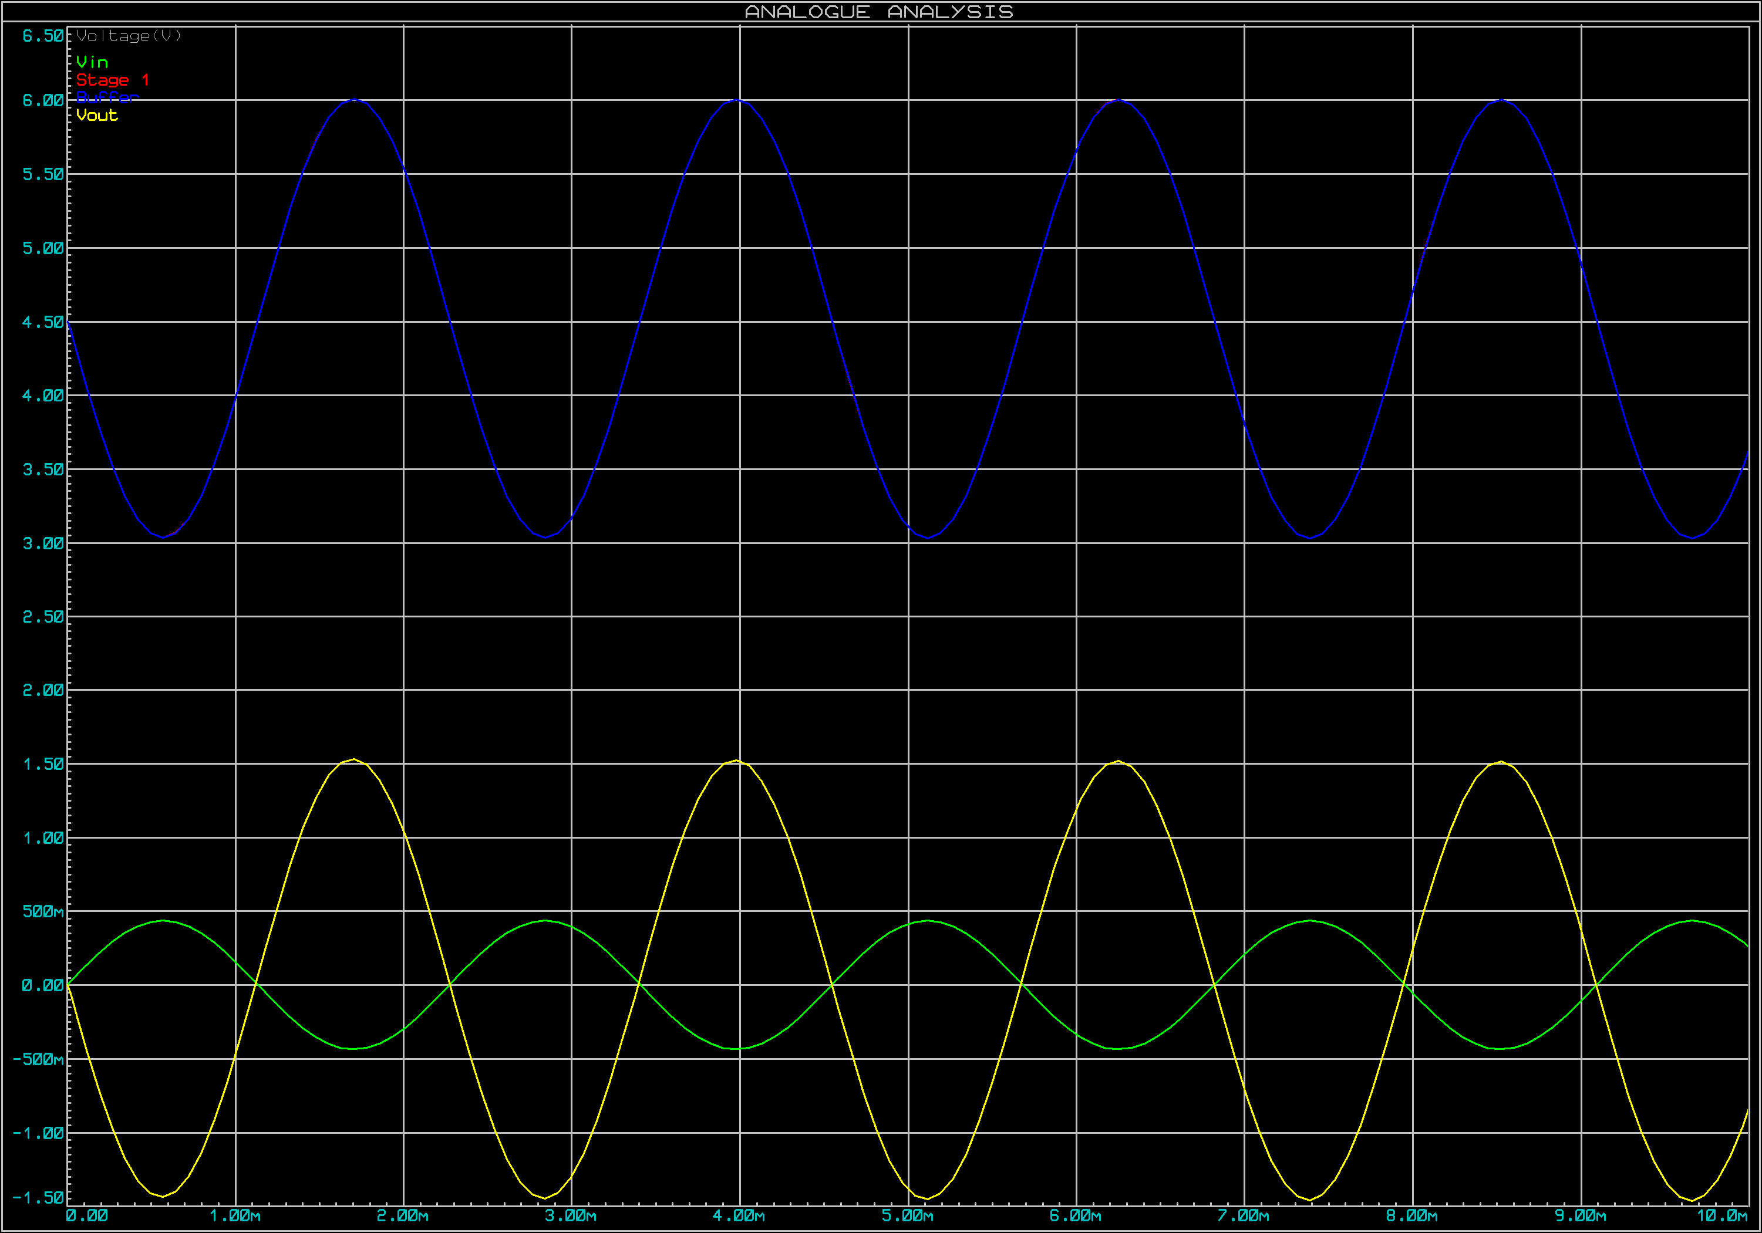 | 16b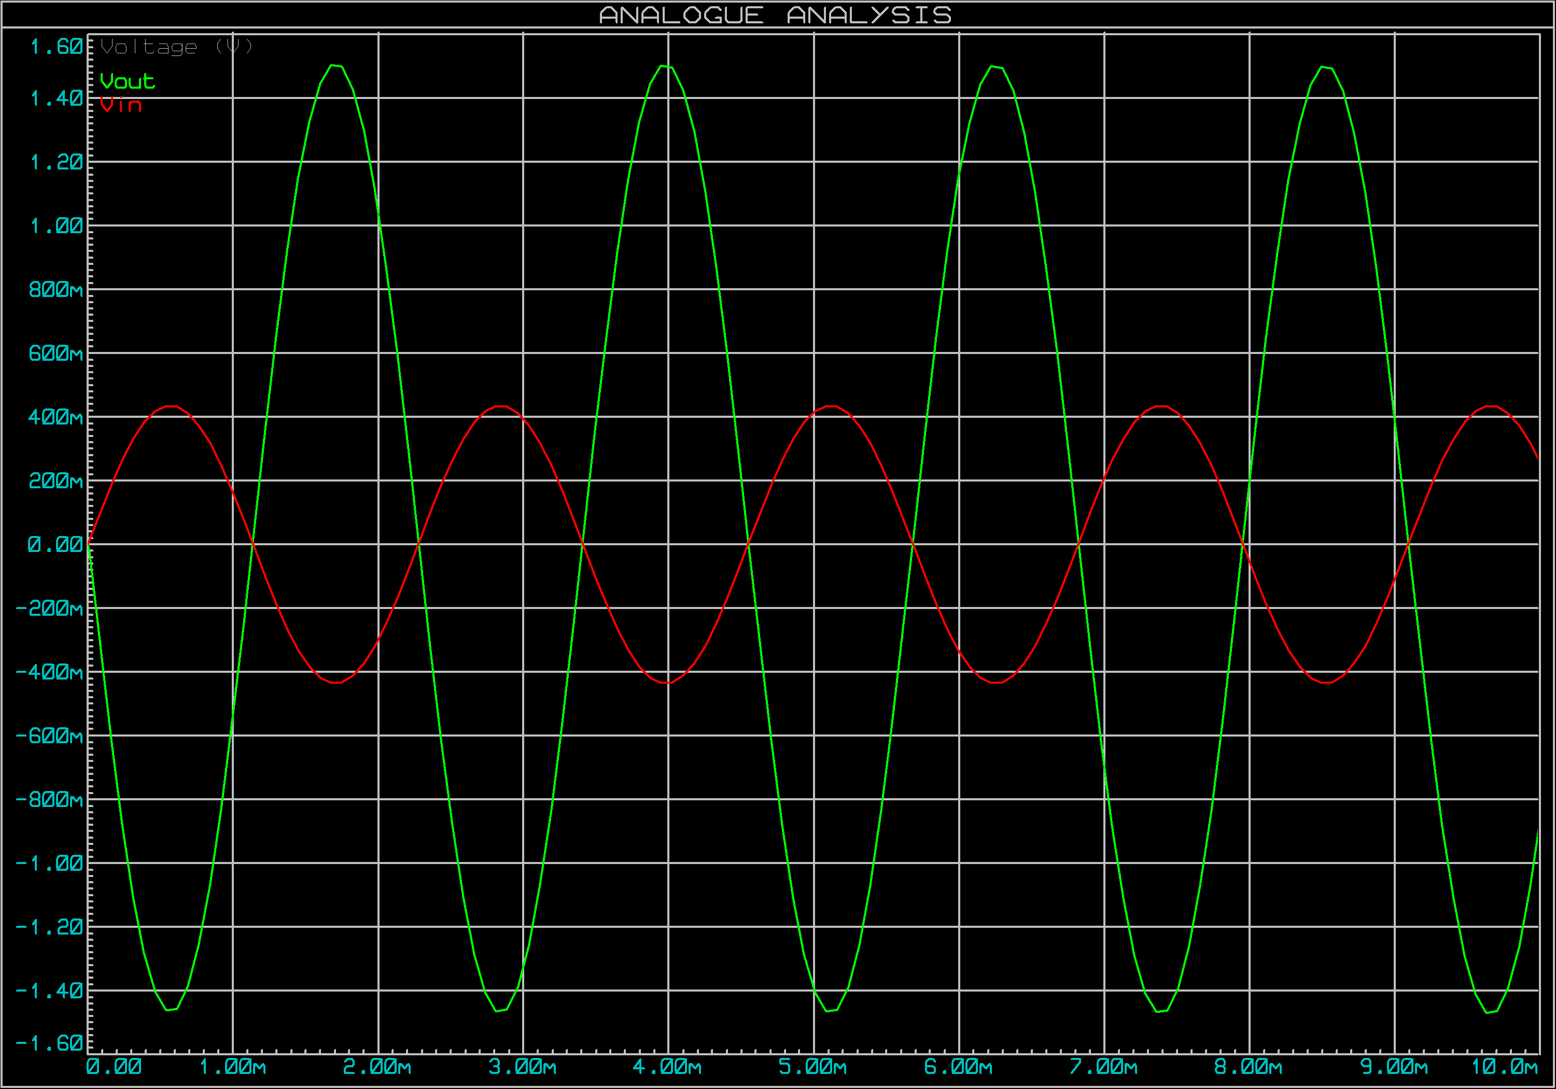
16c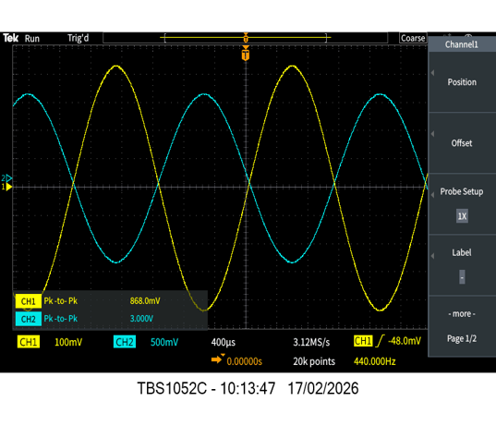 | 16d  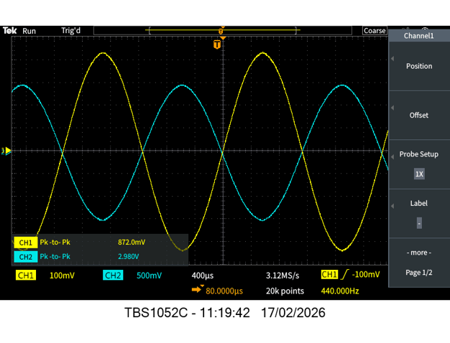
Figure 16: Time-domain waveforms at 440 Hz showing Vin and amplifier output across both stages.
Figure 16(a) shows the Proteus simulation with Vin (green, 0.872 Vpp), Stage 1 output at pin 6 of U1 (red, coincident with blue), Buffer output at pin 6 of U2 (blue, approximately 3 Vpp, centred at 4.5 V) and Vout after C8 (yellow, approximately 3 Vpp, centred at 0 V). Figure 16(b) shows the Proteus simulation with Vin (red) and the final output Vout after C8 (green), centred at 0 V. Figure 16(c) shows the experimental result with Vin (CH1, yellow, 868 mVpp) and Stage 1 output (CH2, cyan, 3.000 Vpp) on the printed circuit board. Figure 16(d) shows the experimental result with Vin (CH1, yellow, 872 mVpp) and Stage 2 output (CH2, cyan, 2.980 Vpp) on the printed circuit board.

Final assembly
The completed printed circuit board assembly is presented in Figure 17. The PCB measures 65 mm × 40 mm with a purple solder mask finish, mounted onto a 3 mm acrylic baseplate using four M3 nylon standoffs secured with M3 nylon nuts, as shown in Figure 17(c) and Figure 17(d). U1 and U2 are seated in DIP IC sockets to allow removal and replacement without desoldering. The completed assembly operated as designed, producing an audible 440 Hz tone from the speaker when driven from the iPhone 14 Pro Max at 70% of maximum volume, confirming that the mechanical and electrical assembly is functional.
17(a)  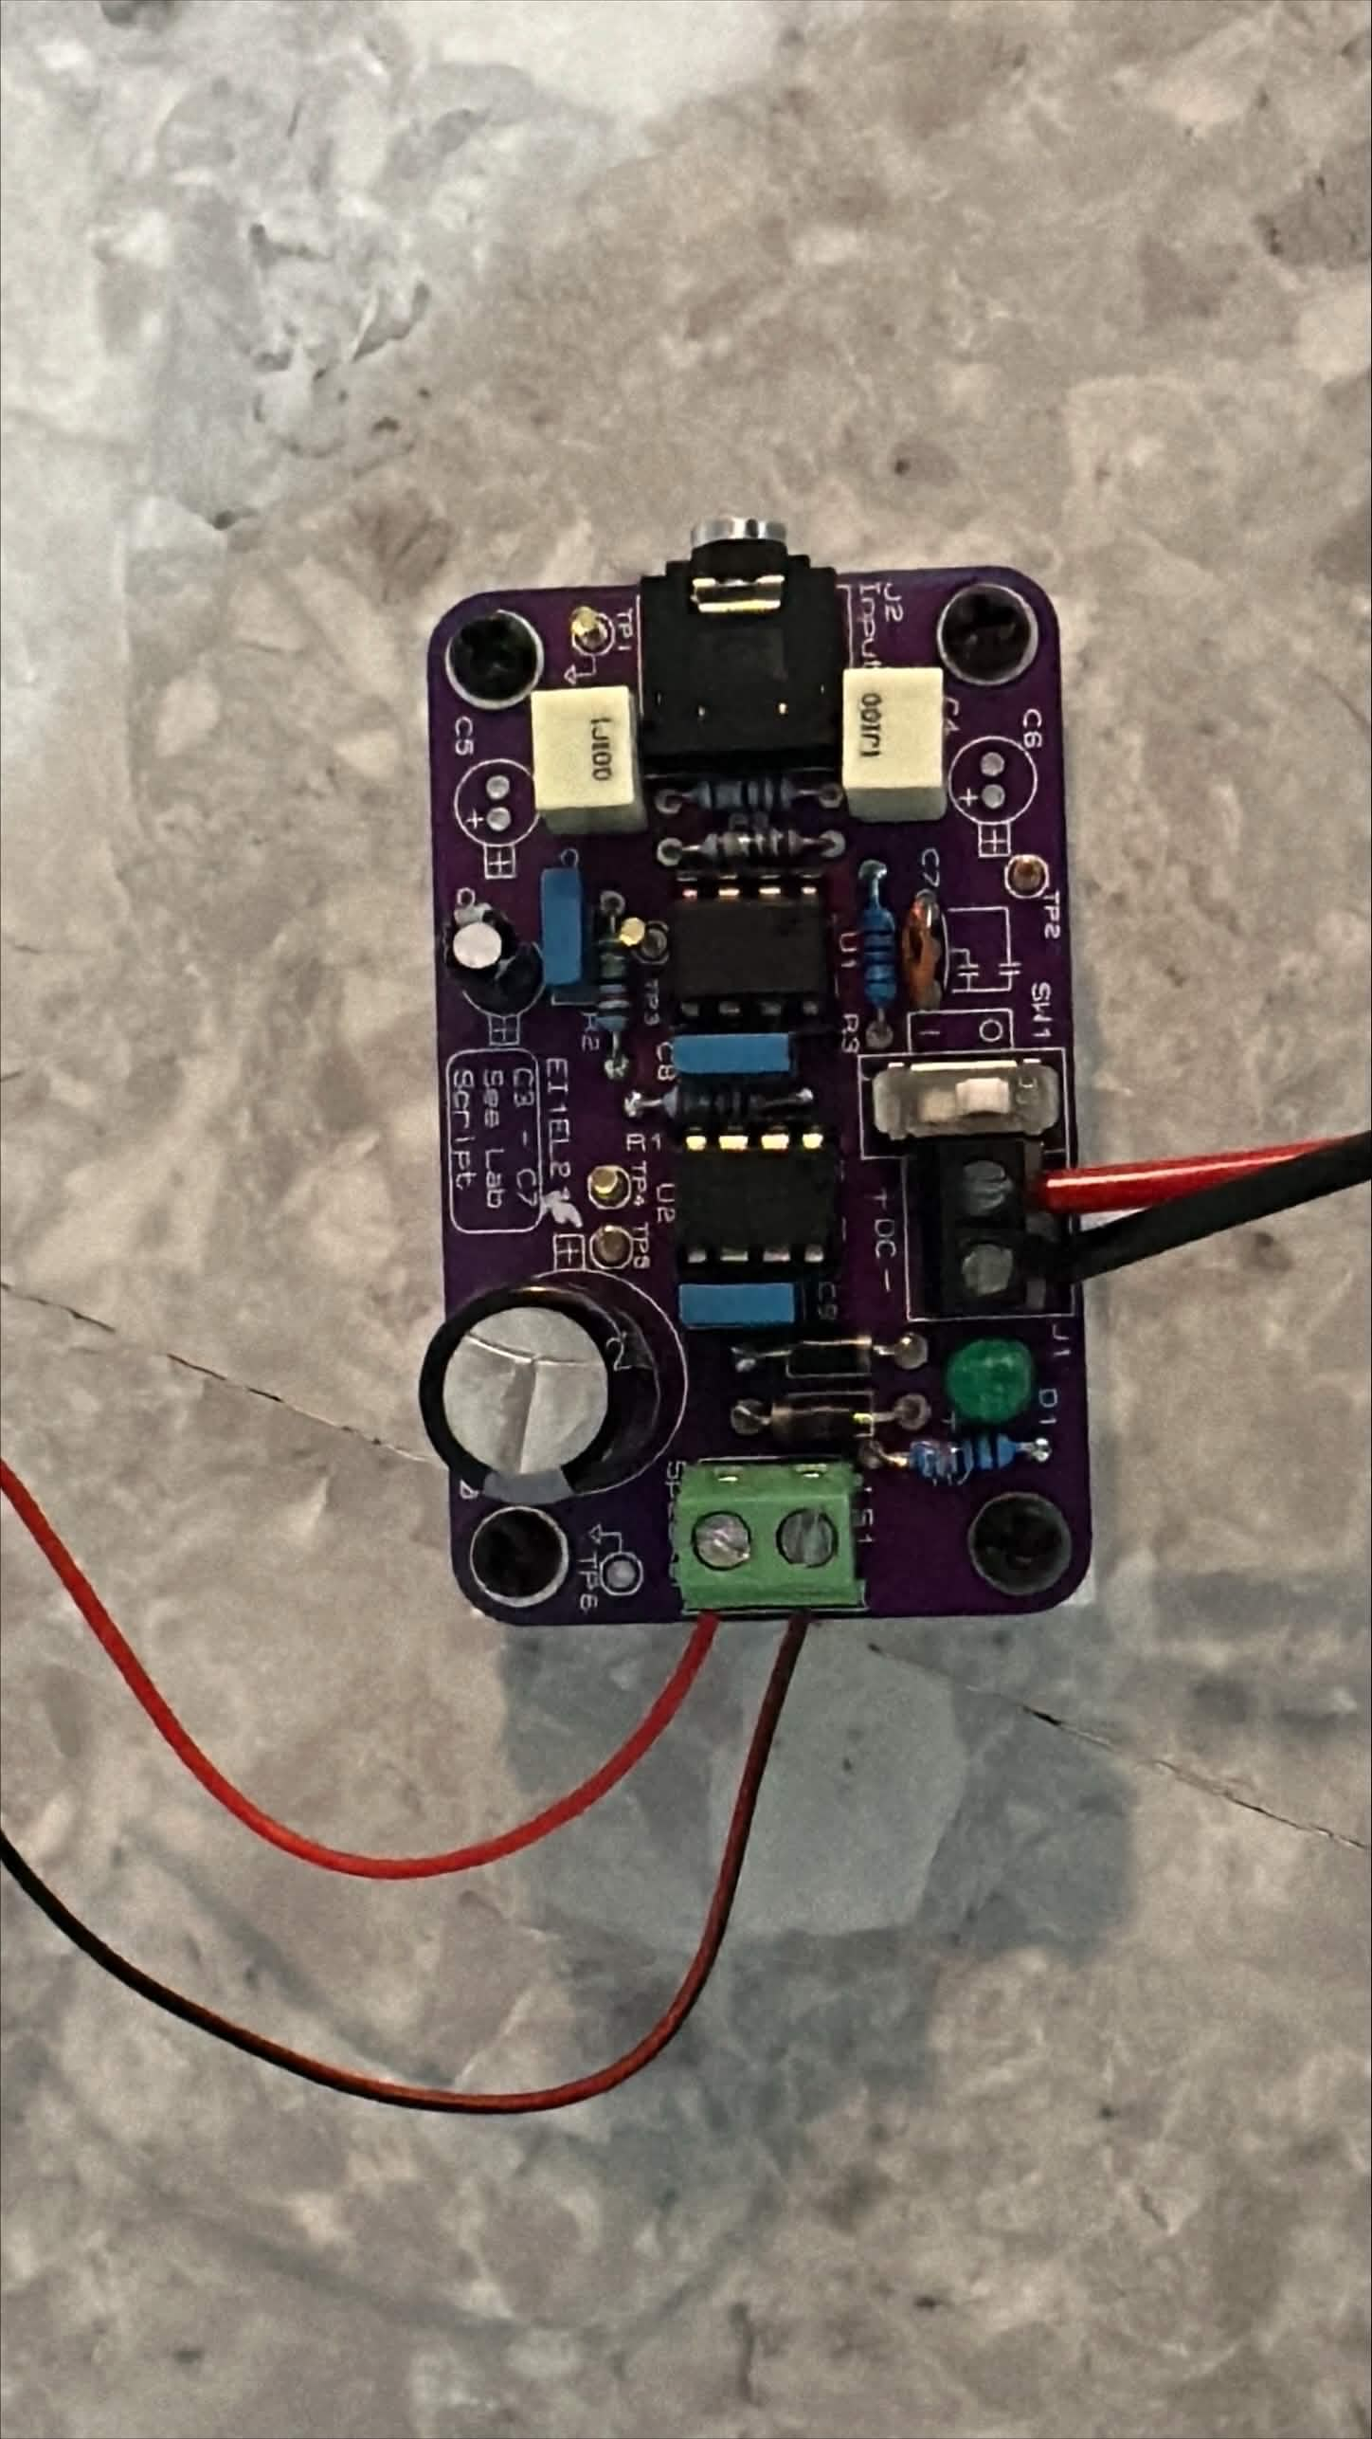 | 17(b)  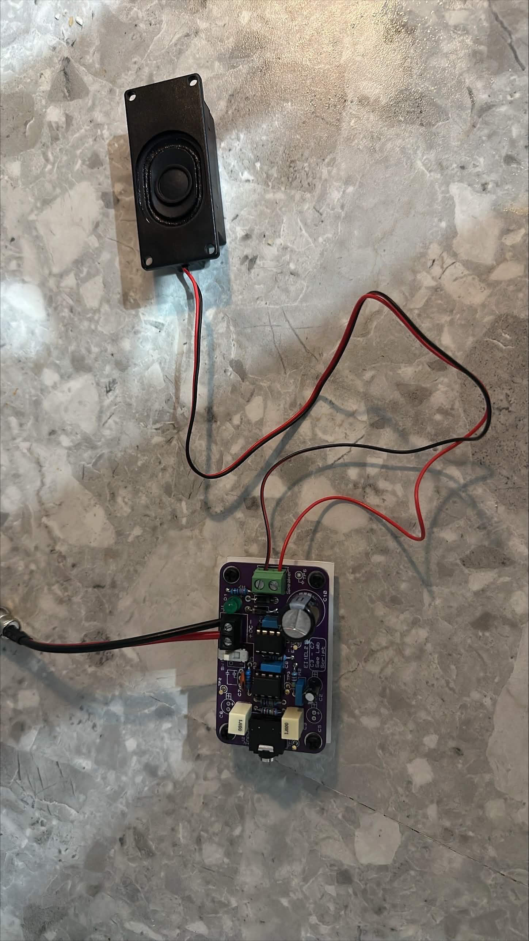
17(c)  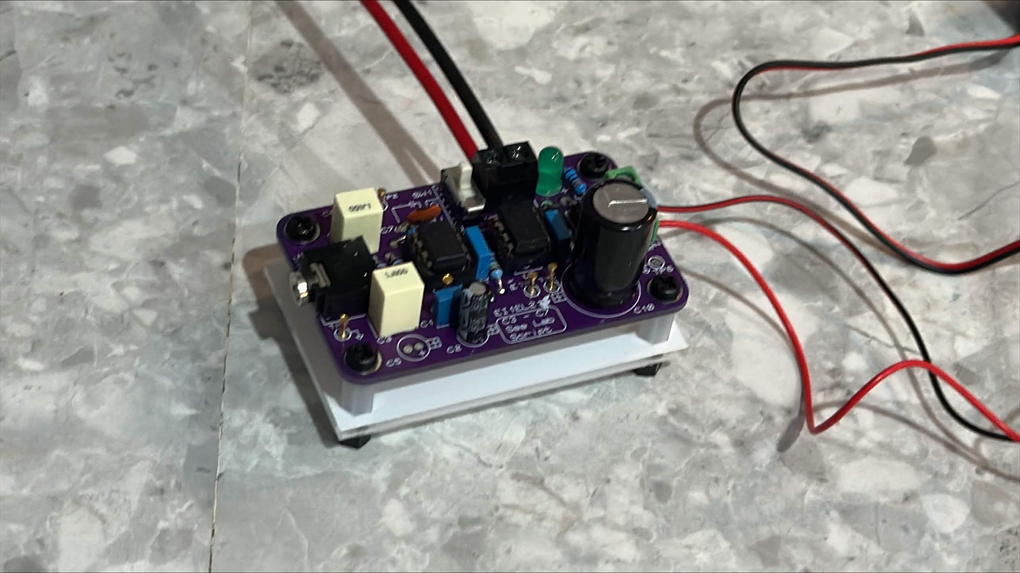 | 17(d)  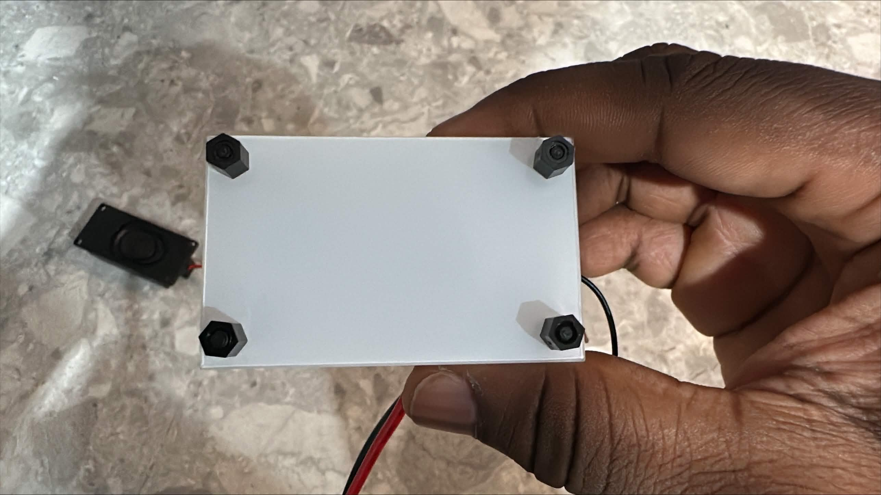
Figure 17: Photographs of the completed printed circuit board assembly.
Figure 17(a) shows a top-down view of the assembled PCB with all components soldered. Figure 17(b) shows the complete system connected to the 8 Ω speaker via J2. Figure 17(c) shows an angled view of the assembly with D1 illuminated. Figure 17(d) shows the underside of the baseplate with M3 nylon standoffs and nuts securing the PCB.

Evaluation and Conclusions
The design met all key performance targets across simulation and hardware testing. The voltage gain was consistent throughout, measuring approximately 10.58 dB on the dual-supply breadboard, approximately 10.81 dB on the single-supply breadboard, approximately 10.77 dB on PCB Stage 1 and 10.67 dB on PCB Stage 2, all within 0.14 dB of the calculated value of 10.67 dB, confirming that the gain set by the ratio of R1 to R2 was correctly calculated and accurately realised. The 3 Vpp output target was met, with Stage 2 delivering 2.980 Vpp at 440 Hz on the PCB, representing agreement to within 0.67% of the design target. The upper cut-off frequency showed close agreement across all conditions, with the PCB Stage 1 measurement of approximately 29.5 kHz and PCB Stage 2 measurement of approximately 30.0 kHz both in reasonable agreement with the calculated value of 28.54 kHz and the simulated value of 27.70 kHz, the small upward shift being consistent with the negative tolerance of C1 within its ±20% tolerance. The lower cut-off frequency of approximately 6.9 Hz on PCB Stage 1 agreed with the calculated value of 6.63 Hz to within 4.1%, consistent with the ±10% tolerance of C2. The PCB Stage 2 lower cut-off of approximately 13.2 Hz is higher than the design value, as expected given the additional high-pass pole introduced by C8 in series with load resistor R7. All measured waveforms at 440 Hz were undistorted sinusoids, confirming linear operation throughout, and the phase inversion of 180° observed at both stages is consistent with the inverting amplifier topology of U1. The PCB layout was functional and well-organised, with decoupling capacitors C3 and C7 positioned immediately adjacent to the supply pins of U1 and U2, respectively. At the design output power of 281 mW delivered to the 8 Ω load, the OPA551 U2 operates well within its maximum continuous power dissipation rating and no thermal management measures such as heatsinking were required for this application [2].
If the design were to be repeated, I would consider the following improvements. The screw terminal power input would be replaced with a dedicated DC barrel jack, accommodating both a 12 V DC adapter and a 9 V PP3 battery via a compatible clip connector, eliminating the risk of incorrect polarity connections and improving usability. A dedicated enclosure would be designed to house the PCB, power supply and speaker as a complete system, incorporating a grille or perforated panel on the speaker-facing surface to allow sound to propagate freely whilst protecting the speaker cone from mechanical damage. A conformal coating would be applied to the finished PCB to improve moisture resistance and long-term solder joint reliability. The 3.5 mm jack input could be replaced with a Bluetooth audio receiver module to eliminate the physical cable connection to the iPhone. Overall, the two-stage inverting amplifier topology with single-supply biasing was demonstrated to be an effective and practical solution for the specified audio amplification application, with all principal design targets met within the expected component tolerance margins.

References
[1] Texas Instruments, "TL071 JFET-Input Operational Amplifiers," SLOS080L, Texas Instruments, Dallas, TX, USA, Feb. 2014. [Online]. Available: https://www.ti.com/lit/ds/symlink/tl071.pdf [Accessed: 3 Mar. 2026].
[2] Texas Instruments, "OPA551 High-Voltage, High-Current Operational Amplifier," SBOS100A, Texas Instruments, Dallas, TX, USA, Jan. 2004. [Online]. Available: https://www.ti.com/lit/ds/symlink/opa551.pdf [Accessed: 2 Mar. 2026].
[3] N. Storey, Electronics: A Systems Approach, 6th ed. Harlow: Pearson, 2017.
[4] P. Horowitz and W. Hill, The Art of Electronics, 3rd ed. New York, NY, USA: Cambridge University Press, 2015.
[5] P. Scherz and S. Monk, Practical Electronics for Inventors, 4th ed. New York, NY, USA: McGraw-Hill, 2016.
[6] H. Zumbahlen, Ed., Linear Circuit Design Handbook. Burlington, MA, USA: Newnes/Elsevier, 2008. [Online]. Available: https://www.analog.com/en/resources/technical-books/linear-circuit-design-handbook.html [Accessed: 27 Feb. 2026].
[7] Texas Instruments, "Handbook of Operational Amplifier Applications," SBOA092B, Texas Instruments, Dallas, TX, USA, Sep. 2016. [Online]. Available: https://www.ti.com/lit/an/sboa092b/sboa092b.pdf [Accessed: 28 Feb. 2026].
[8] Texas Instruments, "A Single-Supply Op-Amp Circuit Collection," Application Report SLOA058, Texas Instruments, Dallas, TX, USA, Nov. 2000.
[9] R. Mancini, Ed., Op Amps for Everyone, Design Guide SLOD006B, Texas Instruments, Dallas, TX, USA, 2002.
[10] Texas Instruments, "Audio Amplifier Design," Application Report SLOA030, Texas Instruments, Dallas, TX, USA, Sep. 1999. [Online]. Available: https://www.ti.com/lit/an/sloa030/sloa030.pdf [Accessed: 3 Mar. 2026].
[11] O. Bishop, Electronics, 3rd ed. Amsterdam: Newnes/Elsevier, 2003.
[12] K. Brindley, Starting Electronics, 4th ed. Oxford: Newnes/Elsevier, 2011.
[13] J. O. Bird, Engineering Mathematics, 8th ed. London: Routledge, 2021.

Appendices
Appendix A presents the bill of materials listing all components by reference designator, value, description and Aston University laboratory stock code. Appendix B presents the full circuit schematic at a size sufficient to read all component values and net connections clearly.

Appendix A - Bill of Materials (BoM)
Table 3: Bill of materials for the audio amplifier design, including component descriptions and Aston University laboratory stock codes.
Category | Quantity | References | Value | Aston Stock Code | Description
Capacitors | 1 | C1 | 68 pF | CER_68P | Ceramic capacitor - upper cut-off frequency
Capacitors | 2 | C2,C6 | 1 µF | POLY_1U | Polyester film capacitor - lower cut-off and input coupling
Capacitors | 3 | C3,C4,C7 | 100 nF | POLY_100N | Polyester film capacitor - supply decoupling
Capacitors | 1 | C5 | 10 µF | ELEC_10U | Electrolytic capacitor - bias network decoupling
Capacitors | 1 | C8 | 2200 µF | ELEC_2200U | Electrolytic capacitor - output DC blocking
Resistors | 1 | R1 | 82 kΩ | MF25_82K | 0.25 W metal film - feedback resistor
Resistors | 4 | R2,R3,R4,R5 | 24 kΩ | MF25_24K | 0.25 W metal film - gain, summing and bias network
Resistors | 1 | R6 | 3.3 kΩ | MF25_3K3 | 0.25 W metal film - LED current limiting
Resistors | 1 | R7 | 8.2 Ω | MF2W_8R2 | 2 W metal film - speaker load resistor
Integrated Circuits | 1 | U1 | TL071CP | TL071CP | JFET-input op-amp - active band-pass filter
Integrated Circuits | 1 | U2 | OPA551PA | OPA551PA | High-current op-amp - unity-gain output buffer
Diodes | 1 | D1 | LED-GREEN_A | LED-GREEN_A | Green LED - power indicator
Diodes | 2 | D2,D3 | 1N4007 | 1N4007 N205 | Rectifier diode - reverse polarity protection
Miscellaneous | 1 | J1 | JACK SOCKET | JACK SOCKET | Stereo 3.5 mm PCB jack socket - audio input
Miscellaneous | 1 | J2 | TBLOCK-I2 | TBLOCK-I2 | 2-way terminal block - speaker output
Miscellaneous | 1 | LS1 | SPEAKER_A | SPEAKER_A | 8 ohm speaker - audio output load
Miscellaneous | 1 | SW1 | SLIDE-SPST_A | SLIDE-SPST_A | SPST slide switch - power switch
Miscellaneous | 1 | TP1 | Bias | TEST_PIN | Test pin - virtual ground bias point
Miscellaneous | 1 | TP2 | Stage 1 | TEST_PIN | Test pin - stage 1 output measurement point
Miscellaneous | 1 | TP3 | Power | TEST_PIN | Test pin - power supply measurement point
Miscellaneous | 1 | TP4 | GND | TEST_PIN | Test pin - circuit ground
Miscellaneous | 1 | TP5 | TEST_PIN | TEST_PIN | Test pin - general purpose

Appendix B - Full circuit diagram
The full circuit schematic for the two-stage audio amplifier is presented below at full page size to allow all component values, reference designators and net connections to be read clearly. The schematic was exported from Proteus as a black and white bitmap and shows the complete two-stage amplifier circuit including all biasing, coupling, decoupling and protection components.
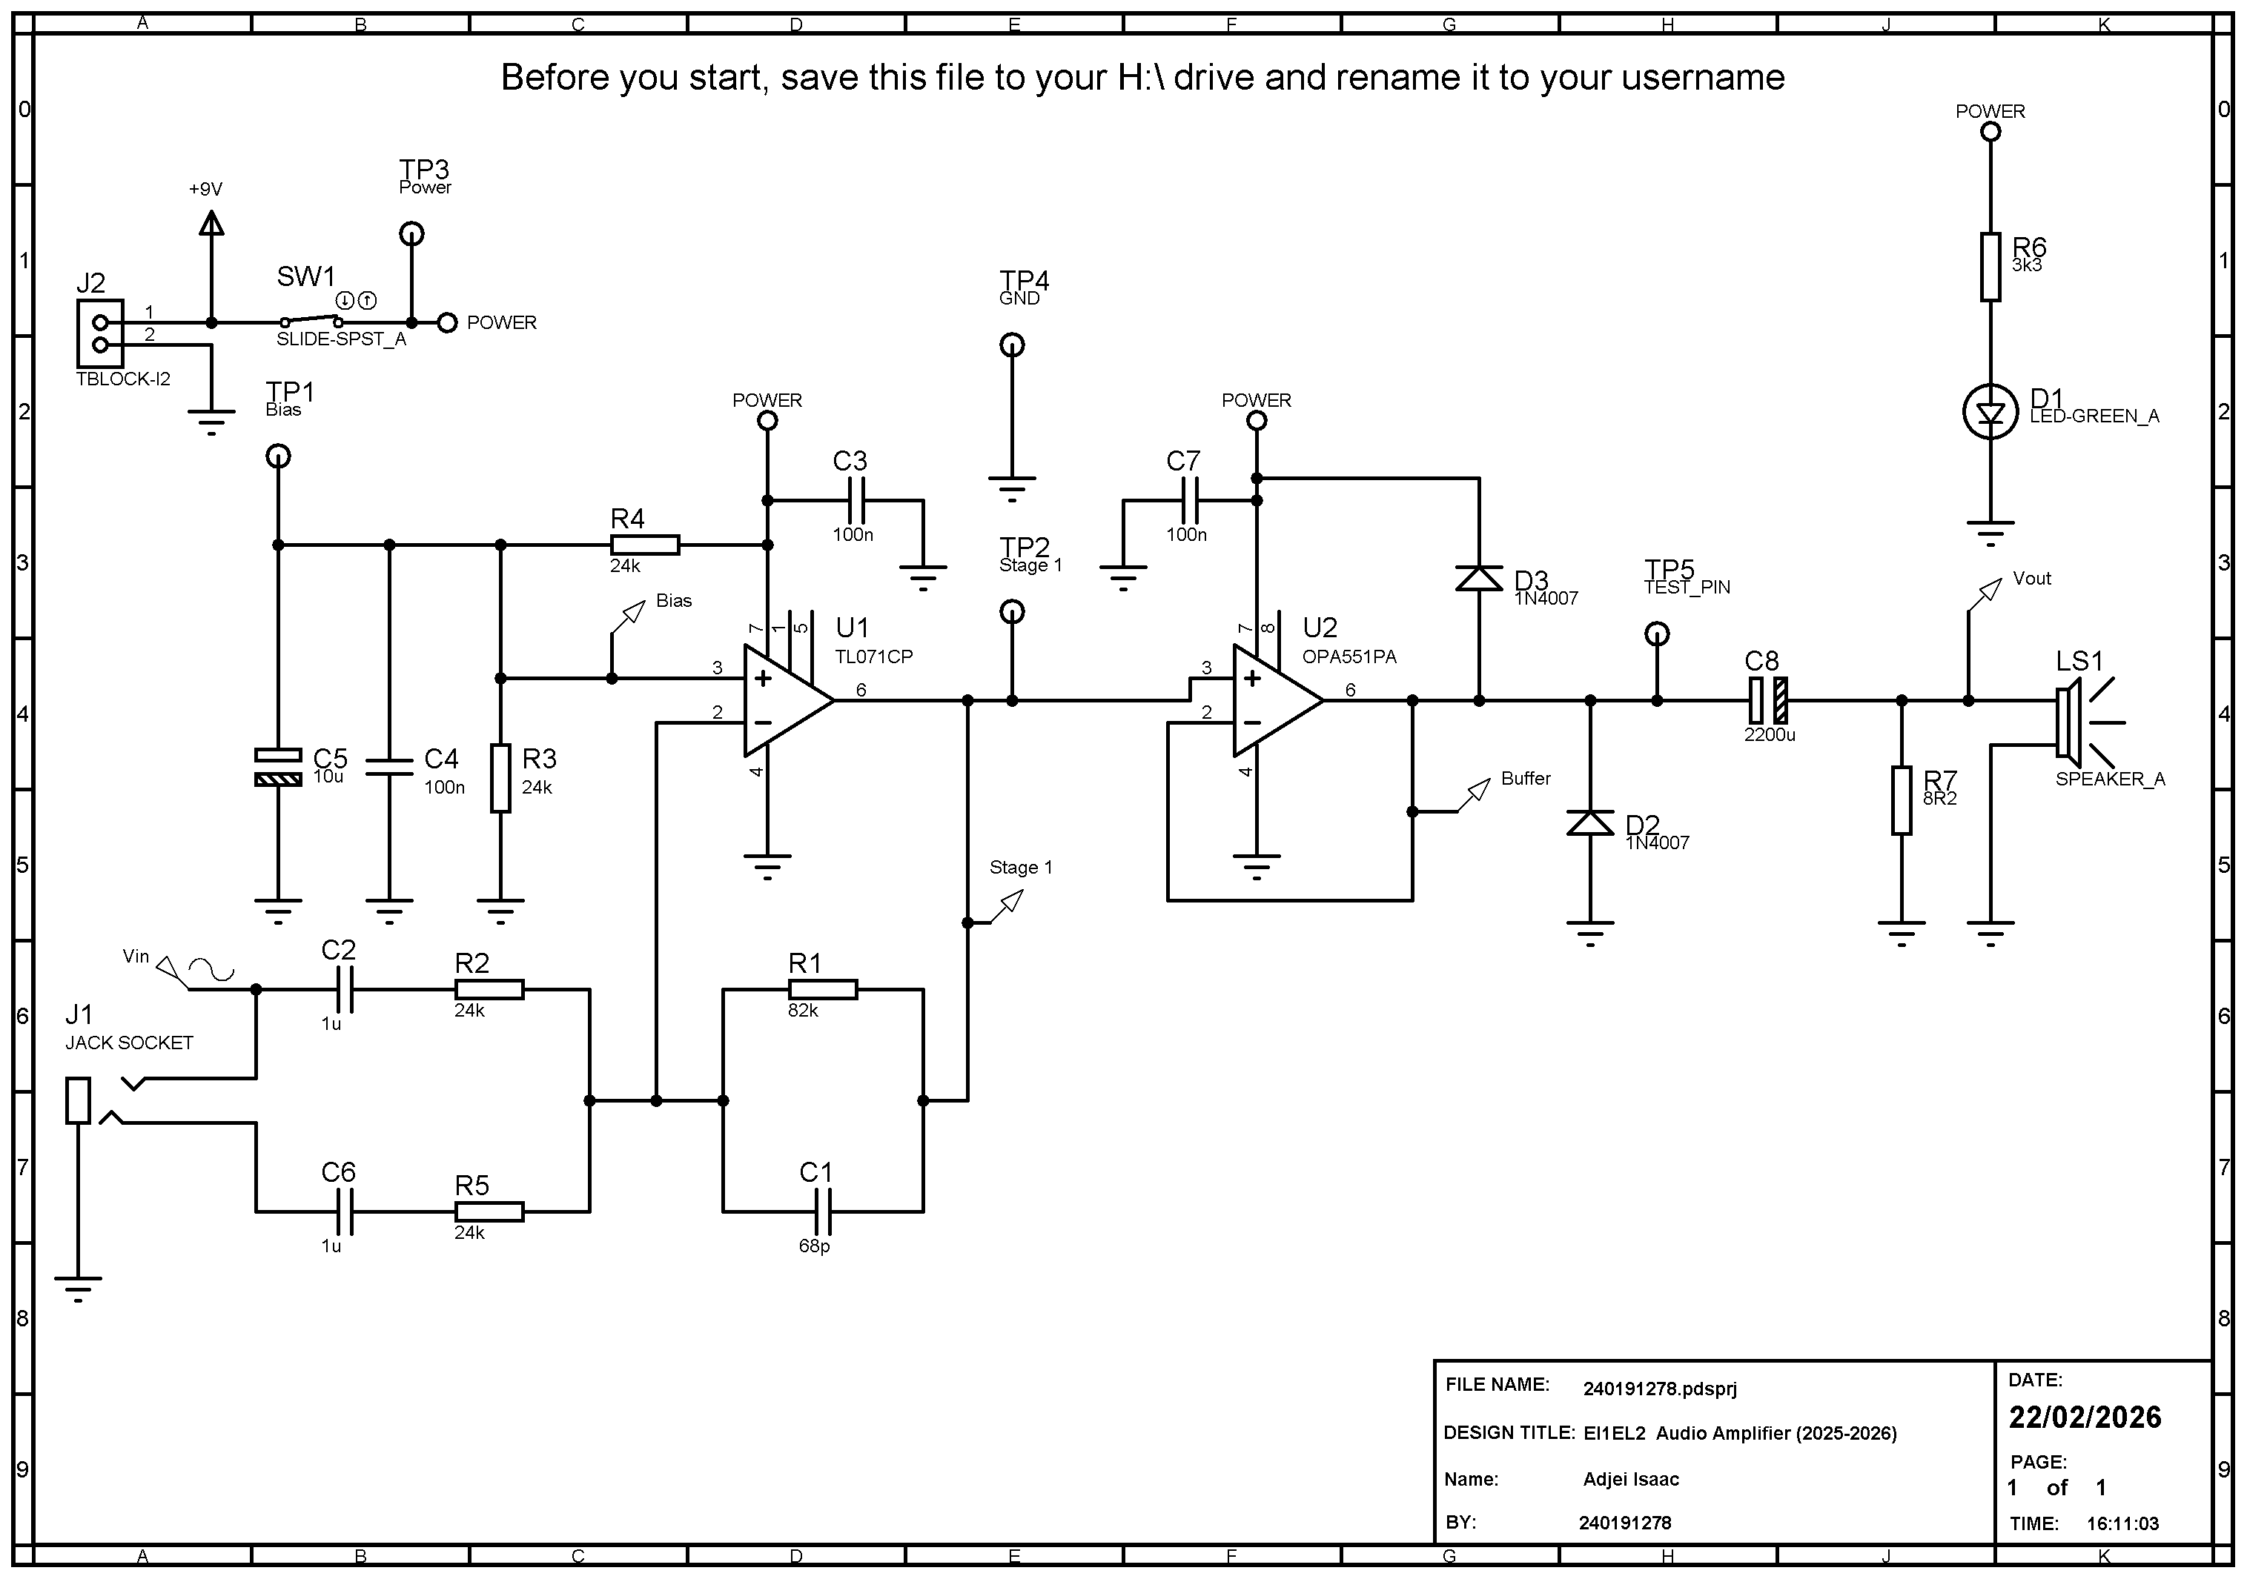
Figure 18: Full circuit schematic of the two-stage audio amplifier exported from Proteus.

